Group Three
XBRL Project Database User Interface -
Appendix-E
Data Communiqué
Gino Gervasio | Theodora Kampelou | Nathalie Neptune | Anand Patil | James Wu
May 5th, 2010

Table of Contents
1. Schema xiii-proj-2009-09-30.xsd 3

Schema xiii-proj-2009-09-30.xsd

Schema xiii-proj-2009-09-30.xsd

schema location: | xiii-proj-2009-09-30.xsd
attribute form default:
element form default: | qualified
targetNamespace: | http://www.xbrl.org/admin/proj

Elements | Complex types
BoilerplateText | ComplexityOfReportingProcessItemType
ComplexityOfReportingProcess | DevelopmentStageItemType
CountryOrRegion | IndustryClassificationFinancialItemType
DateOfLastUpdate | IndustryClassificationNonFinancialSectorsItemType
DevelopmentStage | MarketRegulatorItemType
Filer | NatureOfActivityItemType
IndustryCategorizationFinancial | NatureOfTaxonomyProcessItemType
IndustryClassificationFinancial | OtherOrganizationsItemType
IndustryClassificationNonFinancialSectors | PurposeOfProjectItemType
InstanceDocumentsAccessibleToThirdParties | ScopeItemType
IntellectualPropertyOwner | StatusItemType
LinkToAdditionalProjectInformation | TaxonomyTypeItemType
MarketRegulator | TypesOfDataItemType
MemberOfJurisdiction | UsersOfRecordsItemType
NameOfProject
NatureOfActivity
NatureOfTaxonomyProcess
NumberOfExternalUsersActual
NumberOfPartiesProvidingRecordsToXBRLActivityActual
NumberOfPartiesProvidingRecordsToXBRLActivityPotential
NumberOfRecords
OrganizationInLead
OtherOrganizationsClassification
OtherOrganizationsInvolved
ProjectHeader
ProjectManagerContact
ProjectsList
ProjectSources
PurposeOfProject
Scope
Status
TaxonomyType
TypesOfData
UniqueId
UsersOfRecords

schema location: | xbrl-instance-2003-12-31.xsd
attribute form default:
element form default: | qualified
targetNamespace: | http://www.xbrl.org/2003/instance

Attributes | Elements | Complex types | Simple types | Attr. groups
balance | context | anyURIItemType | dateUnion | essentialNumericItemAttrs
periodType | denominator | base64BinaryItemType | decimalsType | factAttrs
 | divide | booleanItemType | monetary | itemAttrs
 | item | byteItemType | nonZeroDecimal | nonNumericItemAttrs
 | measure | contextEntityType | precisionType | numericItemAttrs
 | numerator | contextPeriodType | pure | tupleAttrs
 | segment | contextScenarioType | shares
 | tuple | dateItemType
 | unit | dateTimeItemType
 | xbrl | decimalItemType
 |  | doubleItemType
 |  | durationItemType
 |  | floatItemType
 |  | fractionItemType
 |  | gDayItemType
 |  | gMonthDayItemType
 |  | gMonthItemType
 |  | gYearItemType
 |  | gYearMonthItemType
 |  | hexBinaryItemType
 |  | integerItemType
 |  | intItemType
 |  | languageItemType
 |  | longItemType
 |  | measuresType
 |  | monetaryItemType
 |  | NameItemType
 |  | NCNameItemType
 |  | negativeIntegerItemType
 |  | nonNegativeIntegerItemType
 |  | nonPositiveIntegerItemType
 |  | normalizedStringItemType
 |  | positiveIntegerItemType
 |  | pureItemType
 |  | QNameItemType
 |  | sharesItemType
 |  | shortItemType
 |  | stringItemType
 |  | timeItemType
 |  | tokenItemType
 |  | unsignedByteItemType
 |  | unsignedIntItemType
 |  | unsignedLongItemType
 |  | unsignedShortItemType

schema location: | xbrl-linkbase-2003-12-31.xsd
attribute form default:
element form default: | qualified
targetNamespace: | http://www.xbrl.org/2003/linkbase

Elements
arcroleRef
arcroleType
calculationArc
calculationLink
definition
definitionArc
definitionLink
documentation
footnote
footnoteArc
footnoteLink
label
labelArc
labelLink
linkbase
linkbaseRef
loc
part
presentationArc
presentationLink
reference
referenceArc
referenceLink
roleRef
roleType
schemaRef
usedOn

schema location: | xl-2003-12-31.xsd
attribute form default: | unqualified
element form default: | qualified
targetNamespace: | http://www.xbrl.org/2003/XLink

Elements | Complex types | Simple types
arc | arcType | nonEmptyURI
documentation | documentationType | useEnum
extended | extendedType
locator | locatorType
resource | resourceType
simple | simpleType
title | titleType

schema location: | xlink-2003-12-31.xsd
attribute form default: | qualified
element form default: | qualified
targetNamespace: | http://www.w3.org/1999/xlink

Attributes
actuate
arcrole
from
href
label
role
show
title
to
type

element BoilerplateText
diagram | 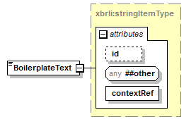
namespace | http://www.xbrl.org/admin/proj
type | xbrli:stringItemType
used by
  element | ProjectHeader
attributes
  Name | Type | Use | Default | Fixed
  id | xsd:ID | optional
  contextRef | xsd:IDREF | required

element ComplexityOfReportingProcess
diagram | 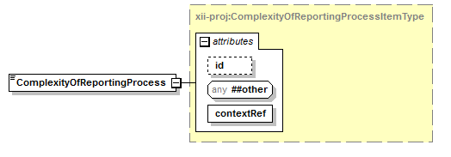
namespace | http://www.xbrl.org/admin/proj
type | xii-proj:ComplexityOfReportingProcessItemType
used by
  element | ProjectHeader
facets
  Kind | Value
  enumeration | Low
  enumeration | Medium
  enumeration | Above_Average
  enumeration | High
attributes
  Name | Type | Use | Default | Fixed
  id | xsd:ID | optional
  contextRef | xsd:IDREF | required

element CountryOrRegion
diagram | 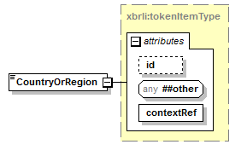
namespace | http://www.xbrl.org/admin/proj
type | xbrli:tokenItemType
used by
  element | ProjectHeader
attributes
  Name | Type | Use | Default | Fixed
  id | xsd:ID | optional
  contextRef | xsd:IDREF | required

element DateOfLastUpdate
diagram | 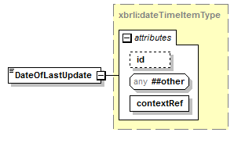
namespace | http://www.xbrl.org/admin/proj
type | xbrli:dateTimeItemType
used by
  element | ProjectHeader
attributes
  Name | Type | Use | Default | Fixed
  id | xsd:ID | optional
  contextRef | xsd:IDREF | required

element DevelopmentStage
diagram | 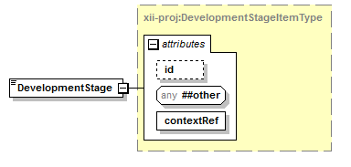
namespace | http://www.xbrl.org/admin/proj
type | xii-proj:DevelopmentStageItemType
used by
  element | ProjectHeader
facets
  Kind | Value
  enumeration | Conception
  enumeration | Prototype
  enumeration | In_testing
  enumeration | Alpha
  enumeration | Beta
  enumeration | Limited_release
  enumeration | Fully_released_-_live
attributes
  Name | Type | Use | Default | Fixed
  id | xsd:ID | optional
  contextRef | xsd:IDREF | required

element Filer
diagram | 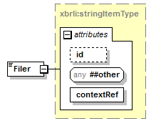
namespace | http://www.xbrl.org/admin/proj
type | xbrli:stringItemType
used by
  element | ProjectHeader
attributes
  Name | Type | Use | Default | Fixed
  id | xsd:ID | optional
  contextRef | xsd:IDREF | required

element IndustryCategorizationFinancial
diagram | 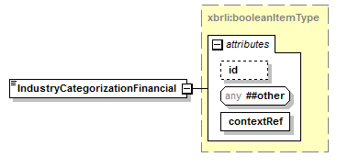
namespace | http://www.xbrl.org/admin/proj
type | xbrli:booleanItemType
used by
  element | ProjectHeader
attributes
  Name | Type | Use | Default | Fixed
  id | xsd:ID | optional
  contextRef | xsd:IDREF | required

element IndustryClassificationFinancial
diagram | 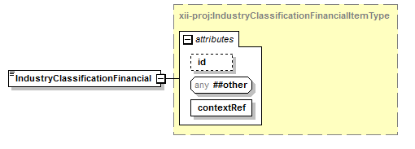
namespace | http://www.xbrl.org/admin/proj
type | xii-proj:IndustryClassificationFinancialItemType
used by
  element | ProjectHeader
facets
  Kind | Value
  enumeration | 6411 Central banking
  enumeration | 6419 Other monetary intermediation
  enumeration | 6430 Trusts, funds and other financial vehicles
  enumeration | 6491 Financial leasing
  enumeration | 6499 Other financial intermediation n.e.c.
  enumeration | 6530 Pension funding
  enumeration | 6611 Administration of financial markets
  enumeration | 6612 Security and commodity contracts dealing activities
  enumeration | 6619 Activities auxiliary to financial intermediation n.e.c.
  enumeration | 6621 Risk and damage evaluation
  enumeration | 6629 Other activities auxiliary to insurance and pension funding
  enumeration | 6630 Fund management activities
attributes
  Name | Type | Use | Default | Fixed
  id | xsd:ID | optional
  contextRef | xsd:IDREF | required

element IndustryClassificationNonFinancialSectors
diagram | 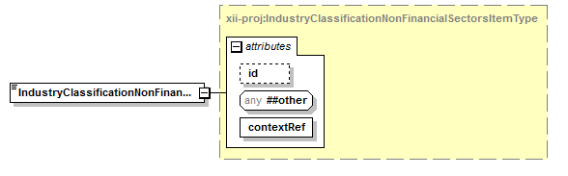
namespace | http://www.xbrl.org/admin/proj
type | xii-proj:IndustryClassificationNonFinancialSectorsItemType
used by
  element | ProjectHeader
facets
  Kind | Value
  enumeration | Exploration &amp; Production 0533
  enumeration | Integrated Oil and Gas 0537
  enumeration | Oil Equipment &amp; Services 0573
  enumeration | Pipelines 0577
  enumeration | Renewable Energy Equipment 0583
  enumeration | Alternative Fuels 0587
  enumeration | Commodity Chemicals 1353
  enumeration | Specialty Chemicals 1357
  enumeration | Foretry 1733
  enumeration | Paper 1737
  enumeration | Aluminium 1753
  enumeration | Nonferrous Metals 1755
  enumeration | Iron &amp; Steel 1757
  enumeration | Coal 1771
  enumeration | Diamonds &amp; Gemstones 1773
  enumeration | Gold Mining 1777
  enumeration | Platinum &amp; Precious Metals 1779
  enumeration | Building Materials &amp; Fixtures 2353
  enumeration | Heavy Construction 2357
  enumeration | Aerospace 2713
  enumeration | Defense 2717
  enumeration | Containers &amp; Packaging 2723
  enumeration | Diversified Industrials 2727
  enumeration | Electrical Components &amp; Equipment 2733
  enumeration | Electronic Equipment 2737
  enumeration | Commercial Vehicles &amp; Trucks 2753
  enumeration | Industrial Machinery 2757
  enumeration | Delivery Services 2771
  enumeration | Marine Transportation 2773
  enumeration | Railroads 2775
  enumeration | Transportation Services 2777
  enumeration | Trucking 2779
  enumeration | Business Support Services 2791
  enumeration | Business Training &amp; Employment Agencies 2793
  enumeration | Financial Administration 2795
  enumeration | Industrial Suppliers 2797
  enumeration | Waste &amp; Disposal Services 2799
  enumeration | Automobiles 3353
  enumeration | Auto Parts 3355
  enumeration | Tires 3357
  enumeration | Brewers 3533
  enumeration | Distillers &amp; Vintners 3535
  enumeration | Soft Drinks 3537
  enumeration | Farming &amp; Fishing 3573
  enumeration | Food Products 3577
  enumeration | Durable Household Products 3722
  enumeration | Nondurable Household Products 3724
  enumeration | Furnishings 3726
  enumeration | Home Construction 3728
  enumeration | Consumer Electronics 3743
  enumeration | Recreational Products 3745
  enumeration | Toys 3747
  enumeration | Clothing and Accessories 3763
  enumeration | Footwear 3765
  enumeration | Personal Products 3767
  enumeration | Tobacco 3785
  enumeration | Health Care Providers 4533
  enumeration | Medical Equipment 4535
  enumeration | Medical Supplies 4537
  enumeration | Biotechnology 4573
  enumeration | Pharmaceuticals 4577
  enumeration | Drug Retailers 5333
  enumeration | Food Retailers and Wholesalers 5337
  enumeration | Apparel Retailers 5371
  enumeration | Broadline Retailers 5373
  enumeration | Home Improvement retailers 5375
  enumeration | Specialized Consumer Services 5377
  enumeration | Speciality Retailers 5379
  enumeration | Broadcasting and Entertainment 5553
  enumeration | Media Agencies 5555
  enumeration | Publishing 5557
  enumeration | Airlines 5751
  enumeration | Gambling 5752
  enumeration | Hotels 5753
  enumeration | Recreational Services 5755
  enumeration | Restaurants and Bars 5757
  enumeration | Travel and Tourism 5759
  enumeration | Fixed Line Telecommunications 6535
  enumeration | Mobile Telecommunications 6575
  enumeration | Conventional Electricity 7535
  enumeration | Alternative Electricity 7537
  enumeration | Gas Distribution 7573
  enumeration | Multiutilities 7575
  enumeration | Water 7577
  enumeration | Computer Services 9533
  enumeration | Internet 9535
  enumeration | Software 9537
  enumeration | Computer Hardware 9572
  enumeration | Electronic Office Equipment 9574
  enumeration | Semiconductors 9576
  enumeration | Telecommunications Equipment 9578
attributes
  Name | Type | Use | Default | Fixed
  id | xsd:ID | optional
  contextRef | xsd:IDREF | required

element InstanceDocumentsAccessibleToThirdParties
diagram | 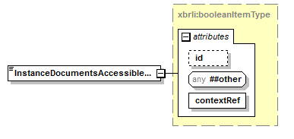
namespace | http://www.xbrl.org/admin/proj
type | xbrli:booleanItemType
used by
  element | ProjectHeader
attributes
  Name | Type | Use | Default | Fixed
  id | xsd:ID | optional
  contextRef | xsd:IDREF | required

element IntellectualPropertyOwner
diagram | 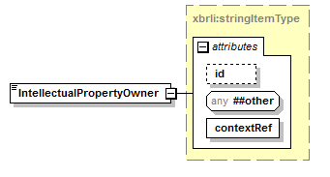
namespace | http://www.xbrl.org/admin/proj
type | xbrli:stringItemType
used by
  element | ProjectHeader
attributes
  Name | Type | Use | Default | Fixed
  id | xsd:ID | optional
  contextRef | xsd:IDREF | required

element LinkToAdditionalProjectInformation
diagram | 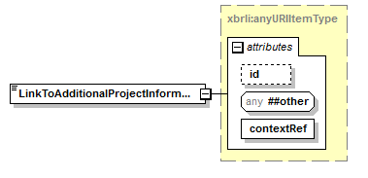
namespace | http://www.xbrl.org/admin/proj
type | xbrli:anyURIItemType
used by
  element | ProjectHeader
attributes
  Name | Type | Use | Default | Fixed
  id | xsd:ID | optional
  contextRef | xsd:IDREF | required

element MarketRegulator
diagram | 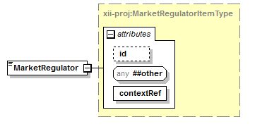
namespace | http://www.xbrl.org/admin/proj
type | xii-proj:MarketRegulatorItemType
used by
  element | ProjectHeader
facets
  Kind | Value
  enumeration | Securities_regulation
  enumeration | Banking_regulation/supervision
  enumeration | Balance_sheet_filing
  enumeration | Revenues_and_tax_filing
  enumeration | Standard_business_reporting
  enumeration | Statistics
attributes
  Name | Type | Use | Default | Fixed
  id | xsd:ID | optional
  contextRef | xsd:IDREF | required

element MemberOfJurisdiction
diagram | 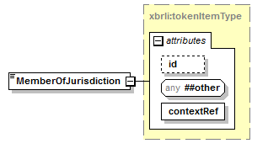
namespace | http://www.xbrl.org/admin/proj
type | xbrli:tokenItemType
used by
  element | ProjectHeader
attributes
  Name | Type | Use | Default | Fixed
  id | xsd:ID | optional
  contextRef | xsd:IDREF | required

element NameOfProject
diagram | 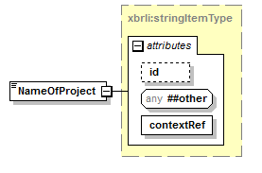
namespace | http://www.xbrl.org/admin/proj
type | xbrli:stringItemType
used by
  element | ProjectHeader
attributes
  Name | Type | Use | Default | Fixed
  id | xsd:ID | optional
  contextRef | xsd:IDREF | required

element NatureOfActivity
diagram | 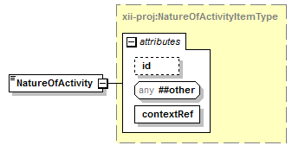
namespace | http://www.xbrl.org/admin/proj
type | xii-proj:NatureOfActivityItemType
used by
  element | ProjectHeader
facets
  Kind | Value
  enumeration | Initiative
  enumeration | Project
  enumeration | Jurisdiction
  enumeration | Jurisdiction_in_development
attributes
  Name | Type | Use | Default | Fixed
  id | xsd:ID | optional
  contextRef | xsd:IDREF | required

element NatureOfTaxonomyProcess
diagram | 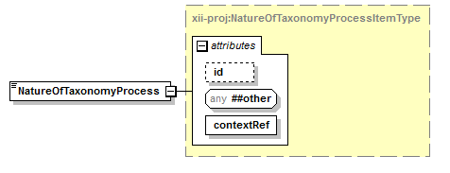
namespace | http://www.xbrl.org/admin/proj
type | xii-proj:NatureOfTaxonomyProcessItemType
used by
  element | ProjectHeader
facets
  Kind | Value
  enumeration | Closed
  enumeration | Extensible
attributes
  Name | Type | Use | Default | Fixed
  id | xsd:ID | optional
  contextRef | xsd:IDREF | required

element NumberOfExternalUsersActual
diagram | 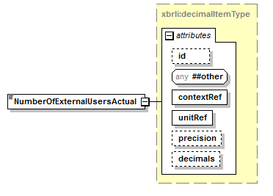
namespace | http://www.xbrl.org/admin/proj
type | xbrli:decimalItemType
used by
  element | ProjectHeader
attributes
  Name | Type | Use | Default | Fixed
  id | xsd:ID | optional
  contextRef | xsd:IDREF | required
  unitRef | xsd:IDREF | required
  precision | xbrli:precisionType | optional
  decimals | xbrli:decimalsType | optional

element NumberOfPartiesProvidingRecordsToXBRLActivityActual
diagram | 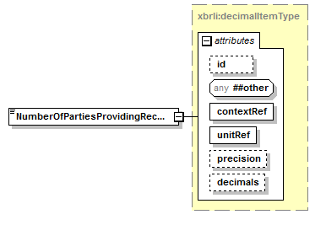
namespace | http://www.xbrl.org/admin/proj
type | xbrli:decimalItemType
used by
  element | ProjectHeader
attributes
  Name | Type | Use | Default | Fixed
  id | xsd:ID | optional
  contextRef | xsd:IDREF | required
  unitRef | xsd:IDREF | required
  precision | xbrli:precisionType | optional
  decimals | xbrli:decimalsType | optional

element NumberOfPartiesProvidingRecordsToXBRLActivityPotential
diagram
namespace | http://www.xbrl.org/admin/proj
type | xbrli:decimalItemType
used by
  element | ProjectHeader
attributes
  Name | Type | Use | Default | Fixed
  id | xsd:ID | optional
  contextRef | xsd:IDREF | required
  unitRef | xsd:IDREF | required
  precision | xbrli:precisionType | optional
  decimals | xbrli:decimalsType | optional

element NumberOfRecords
diagram | 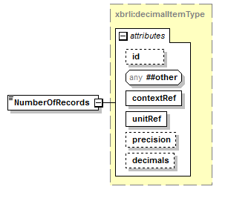
namespace | http://www.xbrl.org/admin/proj
type | xbrli:decimalItemType
used by
  element | ProjectHeader
attributes
  Name | Type | Use | Default | Fixed
  id | xsd:ID | optional
  contextRef | xsd:IDREF | required
  unitRef | xsd:IDREF | required
  precision | xbrli:precisionType | optional
  decimals | xbrli:decimalsType | optional

element OrganizationInLead
diagram | 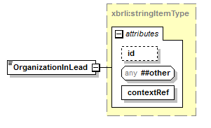
namespace | http://www.xbrl.org/admin/proj
type | xbrli:stringItemType
used by
  element | ProjectHeader
attributes
  Name | Type | Use | Default | Fixed
  id | xsd:ID | optional
  contextRef | xsd:IDREF | required

element OtherOrganizationsClassification
diagram | 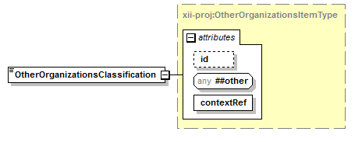
namespace | http://www.xbrl.org/admin/proj
type | xii-proj:OtherOrganizationsItemType
used by
  element | ProjectHeader
facets
  Kind | Value
  enumeration | Government
  enumeration | Administration
  enumeration | NGO
  enumeration | Professional_Association
attributes
  Name | Type | Use | Default | Fixed
  id | xsd:ID | optional
  contextRef | xsd:IDREF | required

element OtherOrganizationsInvolved
diagram | 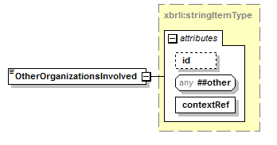
namespace | http://www.xbrl.org/admin/proj
type | xbrli:stringItemType
used by
  element | ProjectHeader
attributes
  Name | Type | Use | Default | Fixed
  id | xsd:ID | optional
  contextRef | xsd:IDREF | required

element ProjectHeader
diagram | 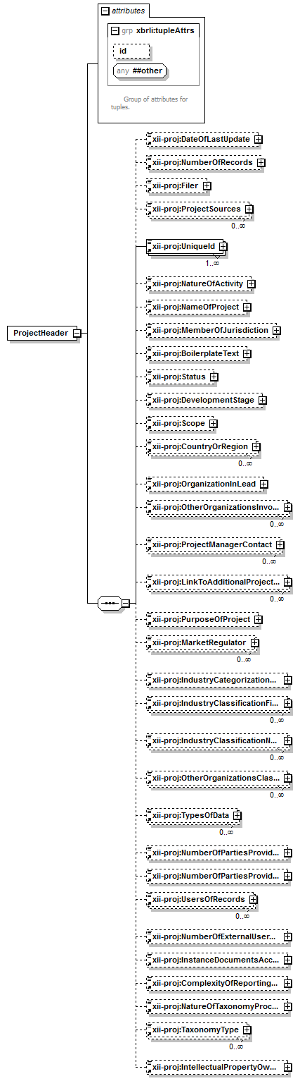
namespace | http://www.xbrl.org/admin/proj
children | xii-proj:DateOfLastUpdate xii-proj:NumberOfRecords xii-proj:Filer xii-proj:ProjectSources xii-proj:UniqueId xii-proj:NatureOfActivity xii-proj:NameOfProject xii-proj:MemberOfJurisdiction xii-proj:BoilerplateText xii-proj:Status xii-proj:DevelopmentStage xii-proj:Scope xii-proj:CountryOrRegion xii-proj:OrganizationInLead xii-proj:OtherOrganizationsInvolved xii-proj:ProjectManagerContact xii-proj:LinkToAdditionalProjectInformation xii-proj:PurposeOfProject xii-proj:MarketRegulator xii-proj:IndustryCategorizationFinancial xii-proj:IndustryClassificationFinancial xii-proj:IndustryClassificationNonFinancialSectors xii-proj:OtherOrganizationsClassification xii-proj:TypesOfData xii-proj:NumberOfPartiesProvidingRecordsToXBRLActivityActual xii-proj:NumberOfPartiesProvidingRecordsToXBRLActivityPotential xii-proj:UsersOfRecords xii-proj:NumberOfExternalUsersActual xii-proj:InstanceDocumentsAccessibleToThirdParties xii-proj:ComplexityOfReportingProcess xii-proj:NatureOfTaxonomyProcess xii-proj:TaxonomyType xii-proj:IntellectualPropertyOwner
used by
  element | ProjectsList
attributes
  Name | Type | Use | Default | Fixed
  id | xsd:ID | optional

element ProjectManagerContact
diagram | 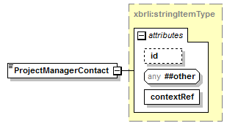
namespace | http://www.xbrl.org/admin/proj
type | xbrli:stringItemType
used by
  element | ProjectHeader
attributes
  Name | Type | Use | Default | Fixed
  id | xsd:ID | optional
  contextRef | xsd:IDREF | required

element ProjectsList
diagram | 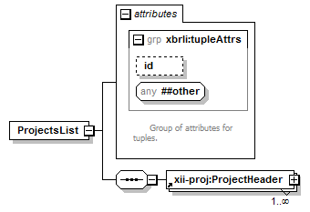
namespace | http://www.xbrl.org/admin/proj
children | xii-proj:ProjectHeader
attributes
  Name | Type | Use | Default | Fixed
  id | xsd:ID | optional

element ProjectSources
diagram | 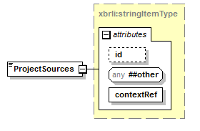
namespace | http://www.xbrl.org/admin/proj
type | xbrli:stringItemType
used by
  element | ProjectHeader
attributes
  Name | Type | Use | Default | Fixed
  id | xsd:ID | optional
  contextRef | xsd:IDREF | required

element PurposeOfProject
diagram | 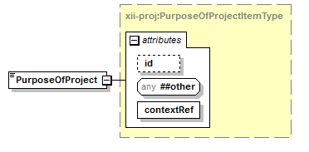
namespace | http://www.xbrl.org/admin/proj
type | xii-proj:PurposeOfProjectItemType
used by
  element | ProjectHeader
facets
  Kind | Value
  enumeration | Market_regulation/supervision
  enumeration | Administration
  enumeration | Statutory
  enumeration | Standard_setting
  enumeration | Commercial
  enumeration | Not-for-profit
attributes
  Name | Type | Use | Default | Fixed
  id | xsd:ID | optional
  contextRef | xsd:IDREF | required

element Scope
diagram | 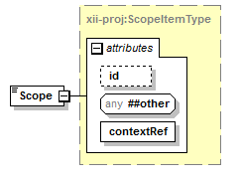
namespace | http://www.xbrl.org/admin/proj
type | xii-proj:ScopeItemType
used by
  element | ProjectHeader
facets
  Kind | Value
  enumeration | National
  enumeration | Regional
  enumeration | Intercontinental
  enumeration | Transcontinental
  enumeration | Intergalactic
attributes
  Name | Type | Use | Default | Fixed
  id | xsd:ID | optional
  contextRef | xsd:IDREF | required

element Status
diagram | 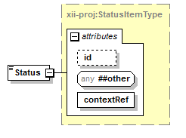
namespace | http://www.xbrl.org/admin/proj
type | xii-proj:StatusItemType
used by
  element | ProjectHeader
facets
  Kind | Value
  enumeration | Initiation
  enumeration | Planning
  enumeration | Execution
  enumeration | Control
  enumeration | Close
  enumeration | Aborted
attributes
  Name | Type | Use | Default | Fixed
  id | xsd:ID | optional
  contextRef | xsd:IDREF | required

element TaxonomyType
diagram | 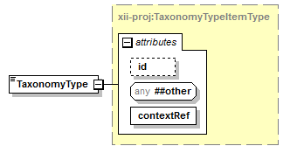
namespace | http://www.xbrl.org/admin/proj
type | xii-proj:TaxonomyTypeItemType
used by
  element | ProjectHeader
facets
  Kind | Value
  enumeration | Regulatory
  enumeration | Analytical
attributes
  Name | Type | Use | Default | Fixed
  id | xsd:ID | optional
  contextRef | xsd:IDREF | required

element TypesOfData
diagram | 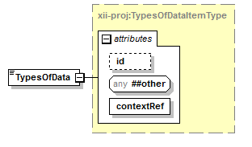
namespace | http://www.xbrl.org/admin/proj
type | xii-proj:TypesOfDataItemType
used by
  element | ProjectHeader
facets
  Kind | Value
  enumeration | Financial
  enumeration | Market
  enumeration | Investment_Product
  enumeration | Extra_Financial
  enumeration | CSR
  enumeration | Payment
  enumeration | Monetary_Transaction
  enumeration | Other
attributes
  Name | Type | Use | Default | Fixed
  id | xsd:ID | optional
  contextRef | xsd:IDREF | required

element UniqueId
diagram | 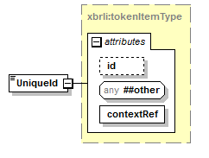
namespace | http://www.xbrl.org/admin/proj
type | xbrli:tokenItemType
used by
  element | ProjectHeader
attributes
  Name | Type | Use | Default | Fixed
  id | xsd:ID | optional
  contextRef | xsd:IDREF | required

element UsersOfRecords
diagram | 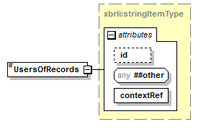
namespace | http://www.xbrl.org/admin/proj
type | xbrli:stringItemType
used by
  element | ProjectHeader
attributes
  Name | Type | Use | Default | Fixed
  id | xsd:ID | optional
  contextRef | xsd:IDREF | required

complexType ComplexityOfReportingProcessItemType
diagram | 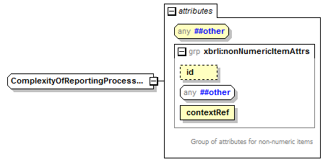
namespace | http://www.xbrl.org/admin/proj
type | restriction of xbrli:tokenItemType
used by
  element | ComplexityOfReportingProcess
facets
  Kind | Value
  enumeration | Low
  enumeration | Medium
  enumeration | Above_Average
  enumeration | High
attributes
  Name | Type | Use | Default | Fixed
  id | xsd:ID | optional
  contextRef | xsd:IDREF | required

complexType DevelopmentStageItemType
diagram | 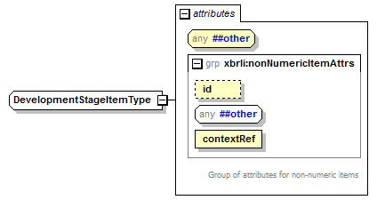
namespace | http://www.xbrl.org/admin/proj
type | restriction of xbrli:tokenItemType
used by
  element | DevelopmentStage
facets
  Kind | Value
  enumeration | Conception
  enumeration | Prototype
  enumeration | In_testing
  enumeration | Alpha
  enumeration | Beta
  enumeration | Limited_release
  enumeration | Fully_released_-_live
attributes
  Name | Type | Use | Default | Fixed
  id | xsd:ID | optional
  contextRef | xsd:IDREF | required

complexType IndustryClassificationFinancialItemType
diagram | 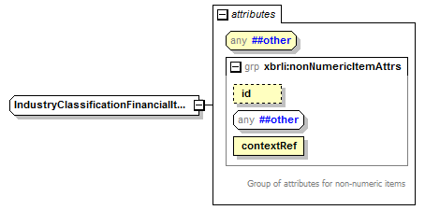
namespace | http://www.xbrl.org/admin/proj
type | restriction of xbrli:tokenItemType
used by
  element | IndustryClassificationFinancial
facets
  Kind | Value
  enumeration | 6411 Central banking
  enumeration | 6419 Other monetary intermediation
  enumeration | 6430 Trusts, funds and other financial vehicles
  enumeration | 6491 Financial leasing
  enumeration | 6499 Other financial intermediation n.e.c.
  enumeration | 6530 Pension funding
  enumeration | 6611 Administration of financial markets
  enumeration | 6612 Security and commodity contracts dealing activities
  enumeration | 6619 Activities auxiliary to financial intermediation n.e.c.
  enumeration | 6621 Risk and damage evaluation
  enumeration | 6629 Other activities auxiliary to insurance and pension funding
  enumeration | 6630 Fund management activities
attributes
  Name | Type | Use | Default | Fixed
  id | xsd:ID | optional
  contextRef | xsd:IDREF | required

complexType IndustryClassificationNonFinancialSectorsItemType
diagram | 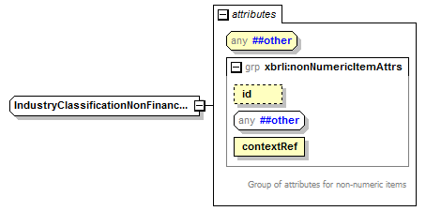
namespace | http://www.xbrl.org/admin/proj
type | restriction of xbrli:tokenItemType
used by
  element | IndustryClassificationNonFinancialSectors
facets
  Kind | Value
  enumeration | Exploration &amp; Production 0533
  enumeration | Integrated Oil and Gas 0537
  enumeration | Oil Equipment &amp; Services 0573
  enumeration | Pipelines 0577
  enumeration | Renewable Energy Equipment 0583
  enumeration | Alternative Fuels 0587
  enumeration | Commodity Chemicals 1353
  enumeration | Specialty Chemicals 1357
  enumeration | Foretry 1733
  enumeration | Paper 1737
  enumeration | Aluminium 1753
  enumeration | Nonferrous Metals 1755
  enumeration | Iron &amp; Steel 1757
  enumeration | Coal 1771
  enumeration | Diamonds &amp; Gemstones 1773
  enumeration | Gold Mining 1777
  enumeration | Platinum &amp; Precious Metals 1779
  enumeration | Building Materials &amp; Fixtures 2353
  enumeration | Heavy Construction 2357
  enumeration | Aerospace 2713
  enumeration | Defense 2717
  enumeration | Containers &amp; Packaging 2723
  enumeration | Diversified Industrials 2727
  enumeration | Electrical Components &amp; Equipment 2733
  enumeration | Electronic Equipment 2737
  enumeration | Commercial Vehicles &amp; Trucks 2753
  enumeration | Industrial Machinery 2757
  enumeration | Delivery Services 2771
  enumeration | Marine Transportation 2773
  enumeration | Railroads 2775
  enumeration | Transportation Services 2777
  enumeration | Trucking 2779
  enumeration | Business Support Services 2791
  enumeration | Business Training &amp; Employment Agencies 2793
  enumeration | Financial Administration 2795
  enumeration | Industrial Suppliers 2797
  enumeration | Waste &amp; Disposal Services 2799
  enumeration | Automobiles 3353
  enumeration | Auto Parts 3355
  enumeration | Tires 3357
  enumeration | Brewers 3533
  enumeration | Distillers &amp; Vintners 3535
  enumeration | Soft Drinks 3537
  enumeration | Farming &amp; Fishing 3573
  enumeration | Food Products 3577
  enumeration | Durable Household Products 3722
  enumeration | Nondurable Household Products 3724
  enumeration | Furnishings 3726
  enumeration | Home Construction 3728
  enumeration | Consumer Electronics 3743
  enumeration | Recreational Products 3745
  enumeration | Toys 3747
  enumeration | Clothing and Accessories 3763
  enumeration | Footwear 3765
  enumeration | Personal Products 3767
  enumeration | Tobacco 3785
  enumeration | Health Care Providers 4533
  enumeration | Medical Equipment 4535
  enumeration | Medical Supplies 4537
  enumeration | Biotechnology 4573
  enumeration | Pharmaceuticals 4577
  enumeration | Drug Retailers 5333
  enumeration | Food Retailers and Wholesalers 5337
  enumeration | Apparel Retailers 5371
  enumeration | Broadline Retailers 5373
  enumeration | Home Improvement retailers 5375
  enumeration | Specialized Consumer Services 5377
  enumeration | Speciality Retailers 5379
  enumeration | Broadcasting and Entertainment 5553
  enumeration | Media Agencies 5555
  enumeration | Publishing 5557
  enumeration | Airlines 5751
  enumeration | Gambling 5752
  enumeration | Hotels 5753
  enumeration | Recreational Services 5755
  enumeration | Restaurants and Bars 5757
  enumeration | Travel and Tourism 5759
  enumeration | Fixed Line Telecommunications 6535
  enumeration | Mobile Telecommunications 6575
  enumeration | Conventional Electricity 7535
  enumeration | Alternative Electricity 7537
  enumeration | Gas Distribution 7573
  enumeration | Multiutilities 7575
  enumeration | Water 7577
  enumeration | Computer Services 9533
  enumeration | Internet 9535
  enumeration | Software 9537
  enumeration | Computer Hardware 9572
  enumeration | Electronic Office Equipment 9574
  enumeration | Semiconductors 9576
  enumeration | Telecommunications Equipment 9578
attributes
  Name | Type | Use | Default | Fixed
  id | xsd:ID | optional
  contextRef | xsd:IDREF | required

complexType MarketRegulatorItemType
diagram | 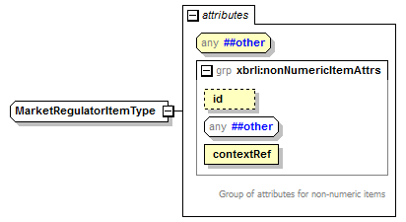
namespace | http://www.xbrl.org/admin/proj
type | restriction of xbrli:tokenItemType
used by
  element | MarketRegulator
facets
  Kind | Value
  enumeration | Securities_regulation
  enumeration | Banking_regulation/supervision
  enumeration | Balance_sheet_filing
  enumeration | Revenues_and_tax_filing
  enumeration | Standard_business_reporting
  enumeration | Statistics
attributes
  Name | Type | Use | Default | Fixed
  id | xsd:ID | optional
  contextRef | xsd:IDREF | required

complexType NatureOfActivityItemType
diagram | 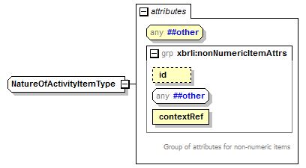
namespace | http://www.xbrl.org/admin/proj
type | restriction of xbrli:tokenItemType
used by
  element | NatureOfActivity
facets
  Kind | Value
  enumeration | Initiative
  enumeration | Project
  enumeration | Jurisdiction
  enumeration | Jurisdiction_in_development
attributes
  Name | Type | Use | Default | Fixed
  id | xsd:ID | optional
  contextRef | xsd:IDREF | required

complexType NatureOfTaxonomyProcessItemType
diagram | 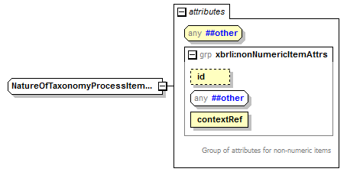
namespace | http://www.xbrl.org/admin/proj
type | restriction of xbrli:tokenItemType
used by
  element | NatureOfTaxonomyProcess
facets
  Kind | Value
  enumeration | Closed
  enumeration | Extensible
attributes
  Name | Type | Use | Default | Fixed
  id | xsd:ID | optional
  contextRef | xsd:IDREF | required

complexType OtherOrganizationsItemType
diagram | 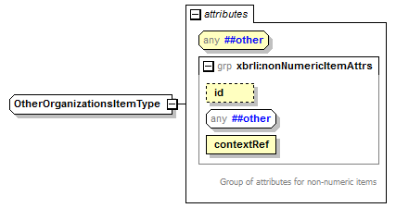
namespace | http://www.xbrl.org/admin/proj
type | restriction of xbrli:tokenItemType
used by
  element | OtherOrganizationsClassification
facets
  Kind | Value
  enumeration | Government
  enumeration | Administration
  enumeration | NGO
  enumeration | Professional_Association
attributes
  Name | Type | Use | Default | Fixed
  id | xsd:ID | optional
  contextRef | xsd:IDREF | required

complexType PurposeOfProjectItemType
diagram | 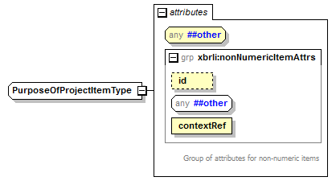
namespace | http://www.xbrl.org/admin/proj
type | restriction of xbrli:tokenItemType
used by
  element | PurposeOfProject
facets
  Kind | Value
  enumeration | Market_regulation/supervision
  enumeration | Administration
  enumeration | Statutory
  enumeration | Standard_setting
  enumeration | Commercial
  enumeration | Not-for-profit
attributes
  Name | Type | Use | Default | Fixed
  id | xsd:ID | optional
  contextRef | xsd:IDREF | required

complexType ScopeItemType
diagram | 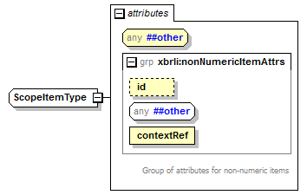
namespace | http://www.xbrl.org/admin/proj
type | restriction of xbrli:tokenItemType
used by
  element | Scope
facets
  Kind | Value
  enumeration | National
  enumeration | Regional
  enumeration | Intercontinental
  enumeration | Transcontinental
  enumeration | Intergalactic
attributes
  Name | Type | Use | Default | Fixed
  id | xsd:ID | optional
  contextRef | xsd:IDREF | required

complexType StatusItemType
diagram | 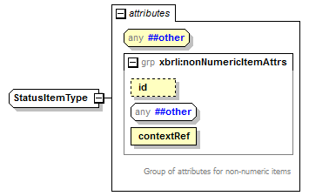
namespace | http://www.xbrl.org/admin/proj
type | restriction of xbrli:tokenItemType
used by
  element | Status
facets
  Kind | Value
  enumeration | Initiation
  enumeration | Planning
  enumeration | Execution
  enumeration | Control
  enumeration | Close
  enumeration | Aborted
attributes
  Name | Type | Use | Default | Fixed
  id | xsd:ID | optional
  contextRef | xsd:IDREF | required

complexType TaxonomyTypeItemType
diagram | 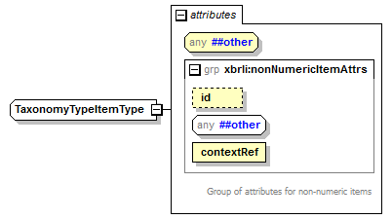
namespace | http://www.xbrl.org/admin/proj
type | restriction of xbrli:tokenItemType
used by
  element | TaxonomyType
facets
  Kind | Value
  enumeration | Regulatory
  enumeration | Analytical
attributes
  Name | Type | Use | Default | Fixed
  id | xsd:ID | optional
  contextRef | xsd:IDREF | required

complexType TypesOfDataItemType
diagram | 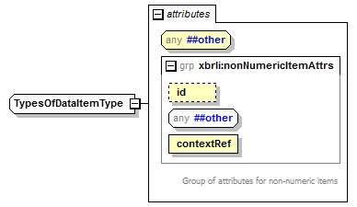
namespace | http://www.xbrl.org/admin/proj
type | restriction of xbrli:tokenItemType
used by
  element | TypesOfData
facets
  Kind | Value
  enumeration | Financial
  enumeration | Market
  enumeration | Investment_Product
  enumeration | Extra_Financial
  enumeration | CSR
  enumeration | Payment
  enumeration | Monetary_Transaction
  enumeration | Other
attributes
  Name | Type | Use | Default | Fixed
  id | xsd:ID | optional
  contextRef | xsd:IDREF | required

complexType UsersOfRecordsItemType
diagram | 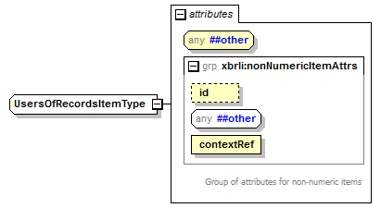
namespace | http://www.xbrl.org/admin/proj
type | restriction of xbrli:tokenItemType
facets
  Kind | Value
  enumeration | Internal
  enumeration | External
attributes
  Name | Type | Use | Default | Fixed
  id | xsd:ID | optional
  contextRef | xsd:IDREF | required

attribute balance
namespace | http://www.xbrl.org/2003/instance
type | restriction of xsd:token
facets
  Kind | Value
  enumeration | debit
  enumeration | credit

attribute periodType
namespace | http://www.xbrl.org/2003/instance
type | restriction of xsd:token
facets
  Kind | Value
  enumeration | instant
  enumeration | duration

element context
diagram | 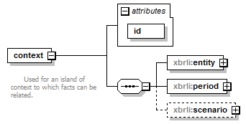
namespace | http://www.xbrl.org/2003/instance
children | xbrli:entity xbrli:period xbrli:scenario
used by
  element | xbrl
attributes
  Name | Type | Use | Default | Fixed
  id | xsd:ID | required

attribute context/@id
type | xsd:ID

element context/entity
diagram | 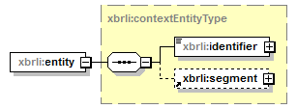
namespace | http://www.xbrl.org/2003/instance
type | xbrli:contextEntityType
children | xbrli:identifier xbrli:segment

element context/period
diagram | 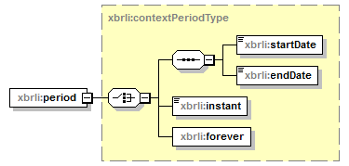
namespace | http://www.xbrl.org/2003/instance
type | xbrli:contextPeriodType
children | xbrli:startDate xbrli:endDate xbrli:instant xbrli:forever

element context/scenario
diagram | 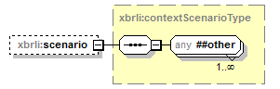
namespace | http://www.xbrl.org/2003/instance
type | xbrli:contextScenarioType

element denominator
diagram | 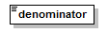
namespace | http://www.xbrl.org/2003/instance
type | xbrli:nonZeroDecimal
used by
  complexType | fractionItemType

element divide
diagram | 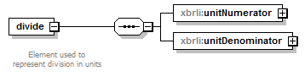
namespace | http://www.xbrl.org/2003/instance
children | xbrli:unitNumerator xbrli:unitDenominator
used by
  element | unit

element divide/unitNumerator
diagram | 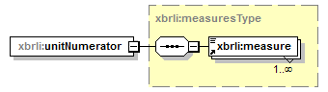
namespace | http://www.xbrl.org/2003/instance
type | xbrli:measuresType
children | xbrli:measure

element divide/unitDenominator
diagram | 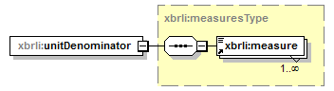
namespace | http://www.xbrl.org/2003/instance
type | xbrli:measuresType
children | xbrli:measure

element item
diagram | 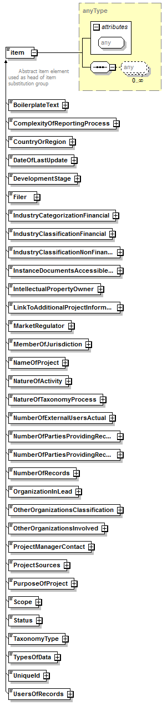
namespace | http://www.xbrl.org/2003/instance
type | xsd:anyType
used by
  element | xbrl
attributes
  Name | Type | Use | Default | Fixed

element measure
diagram | 
namespace | http://www.xbrl.org/2003/instance
type | xsd:QName
used by
  element | unit
  complexType | measuresType

element numerator
diagram | 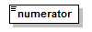
namespace | http://www.xbrl.org/2003/instance
type | xsd:decimal
used by
  complexType | fractionItemType

element segment
diagram | 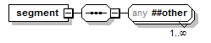
namespace | http://www.xbrl.org/2003/instance
used by
  complexType | contextEntityType

element tuple
diagram | 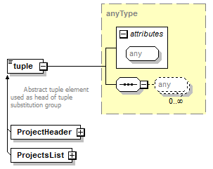
namespace | http://www.xbrl.org/2003/instance
type | xsd:anyType
used by
  element | xbrl
attributes
  Name | Type | Use | Default | Fixed

element unit
diagram | 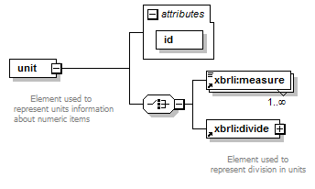
namespace | http://www.xbrl.org/2003/instance
children | xbrli:measure xbrli:divide
used by
  element | xbrl
attributes
  Name | Type | Use | Default | Fixed
  id | xsd:ID | required

attribute unit/@id
type | xsd:ID

element xbrl
diagram | 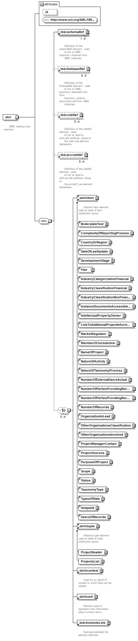
namespace | http://www.xbrl.org/2003/instance
children | link:schemaRef link:linkbaseRef link:roleRef link:arcroleRef xbrli:item xbrli:tuple xbrli:context xbrli:unit link:footnoteLink
attributes
  Name | Type | Use | Default | Fixed
  id | xsd:ID | optional

attribute xbrl/@id
type | xsd:ID

complexType anyURIItemType
diagram | 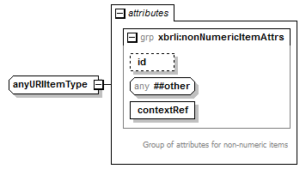
namespace | http://www.xbrl.org/2003/instance
type | extension of xsd:anyURI
used by
  element | LinkToAdditionalProjectInformation
attributes
  Name | Type | Use | Default | Fixed
  id | xsd:ID | optional
  contextRef | xsd:IDREF | required

complexType base64BinaryItemType
diagram | 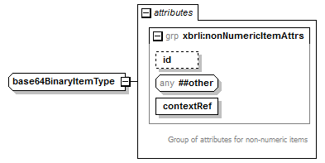
namespace | http://www.xbrl.org/2003/instance
type | extension of xsd:base64Binary
attributes
  Name | Type | Use | Default | Fixed
  id | xsd:ID | optional
  contextRef | xsd:IDREF | required

complexType booleanItemType
diagram | 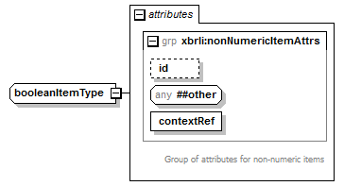
namespace | http://www.xbrl.org/2003/instance
type | extension of xsd:boolean
used by
  elements | IndustryCategorizationFinancial InstanceDocumentsAccessibleToThirdParties
attributes
  Name | Type | Use | Default | Fixed
  id | xsd:ID | optional
  contextRef | xsd:IDREF | required

complexType byteItemType
diagram | 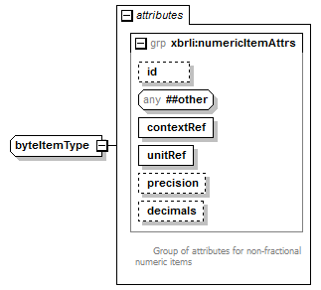
namespace | http://www.xbrl.org/2003/instance
type | extension of xsd:byte
attributes
  Name | Type | Use | Default | Fixed
  id | xsd:ID | optional
  contextRef | xsd:IDREF | required
  unitRef | xsd:IDREF | required
  precision | xbrli:precisionType | optional
  decimals | xbrli:decimalsType | optional

complexType contextEntityType
diagram | 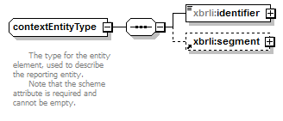
namespace | http://www.xbrl.org/2003/instance
children | xbrli:identifier xbrli:segment
used by
  element | context/entity

element contextEntityType/identifier
diagram | 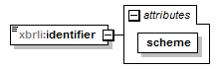
namespace | http://www.xbrl.org/2003/instance
type | extension of xsd:token
attributes
  Name | Type | Use | Default | Fixed
  scheme | derived by: xsd:anyURI | required

attribute contextEntityType/identifier/@scheme
type | restriction of xsd:anyURI

complexType contextPeriodType
diagram | 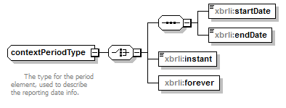
namespace | http://www.xbrl.org/2003/instance
children | xbrli:startDate xbrli:endDate xbrli:instant xbrli:forever
used by
  element | context/period

element contextPeriodType/startDate
diagram | 
namespace | http://www.xbrl.org/2003/instance
type | xbrli:dateUnion

element contextPeriodType/endDate
diagram | 
namespace | http://www.xbrl.org/2003/instance
type | xbrli:dateUnion

element contextPeriodType/instant
diagram | 
namespace | http://www.xbrl.org/2003/instance
type | xbrli:dateUnion

element contextPeriodType/forever
diagram | 
namespace | http://www.xbrl.org/2003/instance

complexType contextScenarioType
diagram | 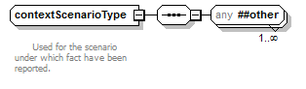
namespace | http://www.xbrl.org/2003/instance
used by
  element | context/scenario

complexType dateItemType
diagram | 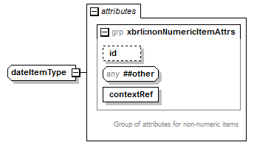
namespace | http://www.xbrl.org/2003/instance
type | extension of xsd:date
attributes
  Name | Type | Use | Default | Fixed
  id | xsd:ID | optional
  contextRef | xsd:IDREF | required

complexType dateTimeItemType
diagram | 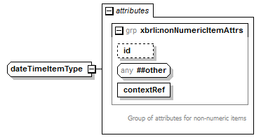
namespace | http://www.xbrl.org/2003/instance
type | extension of xbrli:dateUnion
used by
  element | DateOfLastUpdate
attributes
  Name | Type | Use | Default | Fixed
  id | xsd:ID | optional
  contextRef | xsd:IDREF | required

complexType decimalItemType
diagram | 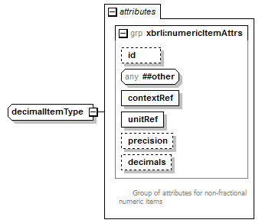
namespace | http://www.xbrl.org/2003/instance
type | extension of xsd:decimal
used by
  elements | NumberOfExternalUsersActual NumberOfPartiesProvidingRecordsToXBRLActivityActual NumberOfPartiesProvidingRecordsToXBRLActivityPotential NumberOfRecords
attributes
  Name | Type | Use | Default | Fixed
  id | xsd:ID | optional
  contextRef | xsd:IDREF | required
  unitRef | xsd:IDREF | required
  precision | xbrli:precisionType | optional
  decimals | xbrli:decimalsType | optional

complexType doubleItemType
diagram | 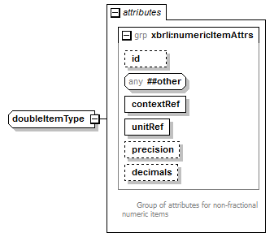
namespace | http://www.xbrl.org/2003/instance
type | extension of xsd:double
attributes
  Name | Type | Use | Default | Fixed
  id | xsd:ID | optional
  contextRef | xsd:IDREF | required
  unitRef | xsd:IDREF | required
  precision | xbrli:precisionType | optional
  decimals | xbrli:decimalsType | optional

complexType durationItemType
diagram | 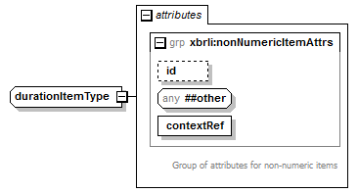
namespace | http://www.xbrl.org/2003/instance
type | extension of xsd:duration
attributes
  Name | Type | Use | Default | Fixed
  id | xsd:ID | optional
  contextRef | xsd:IDREF | required

complexType floatItemType
diagram | 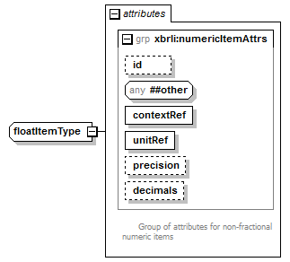
namespace | http://www.xbrl.org/2003/instance
type | extension of xsd:float
attributes
  Name | Type | Use | Default | Fixed
  id | xsd:ID | optional
  contextRef | xsd:IDREF | required
  unitRef | xsd:IDREF | required
  precision | xbrli:precisionType | optional
  decimals | xbrli:decimalsType | optional

complexType fractionItemType
diagram | 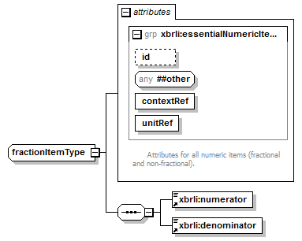
namespace | http://www.xbrl.org/2003/instance
children | xbrli:numerator xbrli:denominator
attributes
  Name | Type | Use | Default | Fixed
  id | xsd:ID | optional
  contextRef | xsd:IDREF | required
  unitRef | xsd:IDREF | required

complexType gDayItemType
diagram | 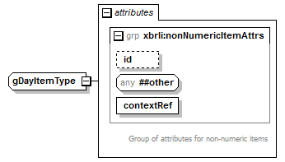
namespace | http://www.xbrl.org/2003/instance
type | extension of xsd:gDay
attributes
  Name | Type | Use | Default | Fixed
  id | xsd:ID | optional
  contextRef | xsd:IDREF | required

complexType gMonthDayItemType
diagram | 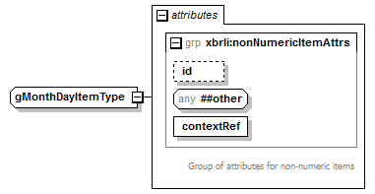
namespace | http://www.xbrl.org/2003/instance
type | extension of xsd:gMonthDay
attributes
  Name | Type | Use | Default | Fixed
  id | xsd:ID | optional
  contextRef | xsd:IDREF | required

complexType gMonthItemType
diagram | 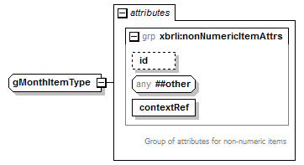
namespace | http://www.xbrl.org/2003/instance
type | extension of xsd:gMonth
attributes
  Name | Type | Use | Default | Fixed
  id | xsd:ID | optional
  contextRef | xsd:IDREF | required

complexType gYearItemType
diagram | 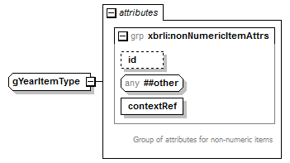
namespace | http://www.xbrl.org/2003/instance
type | extension of xsd:gYear
attributes
  Name | Type | Use | Default | Fixed
  id | xsd:ID | optional
  contextRef | xsd:IDREF | required

complexType gYearMonthItemType
diagram | 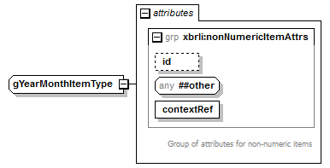
namespace | http://www.xbrl.org/2003/instance
type | extension of xsd:gYearMonth
attributes
  Name | Type | Use | Default | Fixed
  id | xsd:ID | optional
  contextRef | xsd:IDREF | required

complexType hexBinaryItemType
diagram | 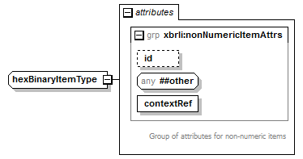
namespace | http://www.xbrl.org/2003/instance
type | extension of xsd:hexBinary
attributes
  Name | Type | Use | Default | Fixed
  id | xsd:ID | optional
  contextRef | xsd:IDREF | required

complexType integerItemType
diagram | 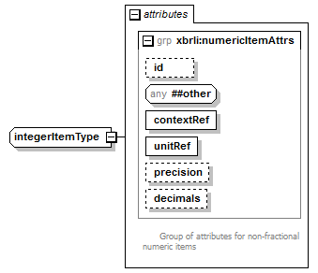
namespace | http://www.xbrl.org/2003/instance
type | extension of xsd:integer
attributes
  Name | Type | Use | Default | Fixed
  id | xsd:ID | optional
  contextRef | xsd:IDREF | required
  unitRef | xsd:IDREF | required
  precision | xbrli:precisionType | optional
  decimals | xbrli:decimalsType | optional

complexType intItemType
diagram | 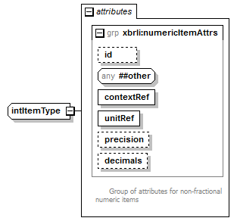
namespace | http://www.xbrl.org/2003/instance
type | extension of xsd:int
attributes
  Name | Type | Use | Default | Fixed
  id | xsd:ID | optional
  contextRef | xsd:IDREF | required
  unitRef | xsd:IDREF | required
  precision | xbrli:precisionType | optional
  decimals | xbrli:decimalsType | optional

complexType languageItemType
diagram | 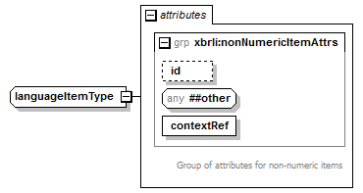
namespace | http://www.xbrl.org/2003/instance
type | extension of xsd:language
attributes
  Name | Type | Use | Default | Fixed
  id | xsd:ID | optional
  contextRef | xsd:IDREF | required

complexType longItemType
diagram | 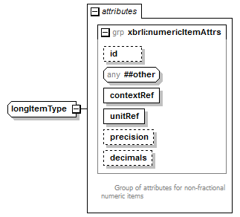
namespace | http://www.xbrl.org/2003/instance
type | extension of xsd:long
attributes
  Name | Type | Use | Default | Fixed
  id | xsd:ID | optional
  contextRef | xsd:IDREF | required
  unitRef | xsd:IDREF | required
  precision | xbrli:precisionType | optional
  decimals | xbrli:decimalsType | optional

complexType measuresType
diagram | 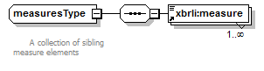
namespace | http://www.xbrl.org/2003/instance
children | xbrli:measure
used by
  elements | divide/unitDenominator divide/unitNumerator

complexType monetaryItemType
diagram | 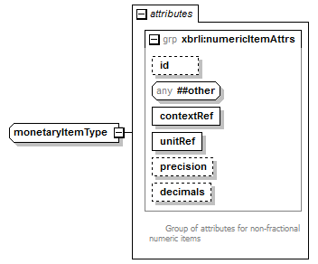
namespace | http://www.xbrl.org/2003/instance
type | extension of xbrli:monetary
attributes
  Name | Type | Use | Default | Fixed
  id | xsd:ID | optional
  contextRef | xsd:IDREF | required
  unitRef | xsd:IDREF | required
  precision | xbrli:precisionType | optional
  decimals | xbrli:decimalsType | optional

complexType NameItemType
diagram | 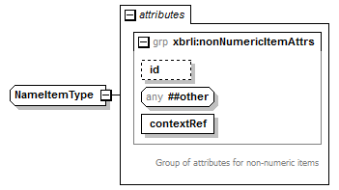
namespace | http://www.xbrl.org/2003/instance
type | extension of xsd:Name
attributes
  Name | Type | Use | Default | Fixed
  id | xsd:ID | optional
  contextRef | xsd:IDREF | required

complexType NCNameItemType
diagram | 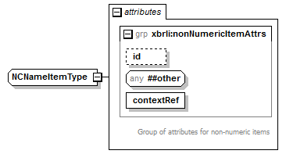
namespace | http://www.xbrl.org/2003/instance
type | extension of xsd:NCName
attributes
  Name | Type | Use | Default | Fixed
  id | xsd:ID | optional
  contextRef | xsd:IDREF | required

complexType negativeIntegerItemType
diagram | 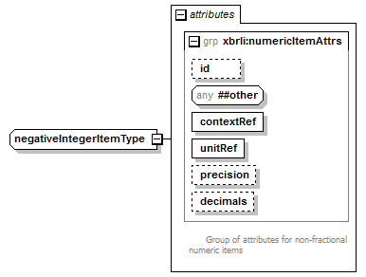
namespace | http://www.xbrl.org/2003/instance
type | extension of xsd:negativeInteger
attributes
  Name | Type | Use | Default | Fixed
  id | xsd:ID | optional
  contextRef | xsd:IDREF | required
  unitRef | xsd:IDREF | required
  precision | xbrli:precisionType | optional
  decimals | xbrli:decimalsType | optional

complexType nonNegativeIntegerItemType
diagram | 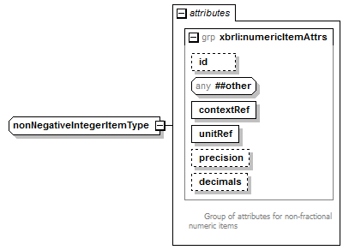
namespace | http://www.xbrl.org/2003/instance
type | extension of xsd:nonNegativeInteger
attributes
  Name | Type | Use | Default | Fixed
  id | xsd:ID | optional
  contextRef | xsd:IDREF | required
  unitRef | xsd:IDREF | required
  precision | xbrli:precisionType | optional
  decimals | xbrli:decimalsType | optional

complexType nonPositiveIntegerItemType
diagram | 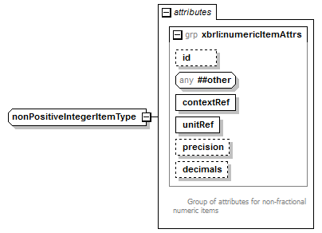
namespace | http://www.xbrl.org/2003/instance
type | extension of xsd:nonPositiveInteger
attributes
  Name | Type | Use | Default | Fixed
  id | xsd:ID | optional
  contextRef | xsd:IDREF | required
  unitRef | xsd:IDREF | required
  precision | xbrli:precisionType | optional
  decimals | xbrli:decimalsType | optional

complexType normalizedStringItemType
diagram | 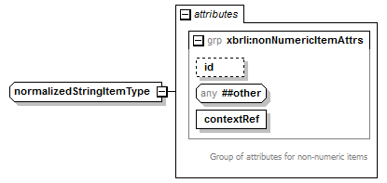
namespace | http://www.xbrl.org/2003/instance
type | extension of xsd:normalizedString
attributes
  Name | Type | Use | Default | Fixed
  id | xsd:ID | optional
  contextRef | xsd:IDREF | required

complexType positiveIntegerItemType
diagram | 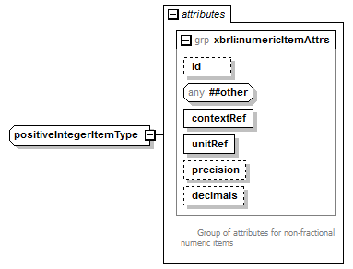
namespace | http://www.xbrl.org/2003/instance
type | extension of xsd:positiveInteger
attributes
  Name | Type | Use | Default | Fixed
  id | xsd:ID | optional
  contextRef | xsd:IDREF | required
  unitRef | xsd:IDREF | required
  precision | xbrli:precisionType | optional
  decimals | xbrli:decimalsType | optional

complexType pureItemType
diagram | 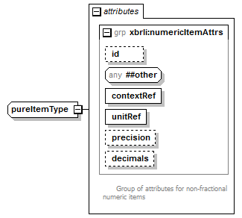
namespace | http://www.xbrl.org/2003/instance
type | extension of xbrli:pure
attributes
  Name | Type | Use | Default | Fixed
  id | xsd:ID | optional
  contextRef | xsd:IDREF | required
  unitRef | xsd:IDREF | required
  precision | xbrli:precisionType | optional
  decimals | xbrli:decimalsType | optional

complexType QNameItemType
diagram | 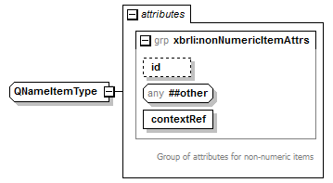
namespace | http://www.xbrl.org/2003/instance
type | extension of xsd:QName
attributes
  Name | Type | Use | Default | Fixed
  id | xsd:ID | optional
  contextRef | xsd:IDREF | required

complexType sharesItemType
diagram | 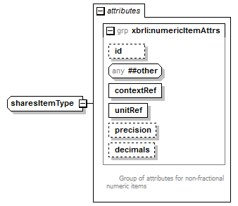
namespace | http://www.xbrl.org/2003/instance
type | extension of xbrli:shares
attributes
  Name | Type | Use | Default | Fixed
  id | xsd:ID | optional
  contextRef | xsd:IDREF | required
  unitRef | xsd:IDREF | required
  precision | xbrli:precisionType | optional
  decimals | xbrli:decimalsType | optional

complexType shortItemType
diagram | 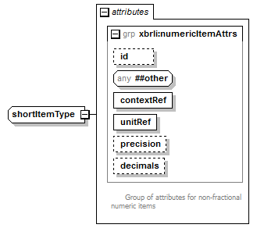
namespace | http://www.xbrl.org/2003/instance
type | extension of xsd:short
attributes
  Name | Type | Use | Default | Fixed
  id | xsd:ID | optional
  contextRef | xsd:IDREF | required
  unitRef | xsd:IDREF | required
  precision | xbrli:precisionType | optional
  decimals | xbrli:decimalsType | optional

complexType stringItemType
diagram | 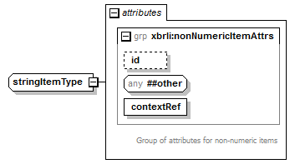
namespace | http://www.xbrl.org/2003/instance
type | extension of xsd:string
used by
  elements | BoilerplateText Filer IntellectualPropertyOwner NameOfProject OrganizationInLead OtherOrganizationsInvolved ProjectManagerContact ProjectSources UsersOfRecords
attributes
  Name | Type | Use | Default | Fixed
  id | xsd:ID | optional
  contextRef | xsd:IDREF | required

complexType timeItemType
diagram | 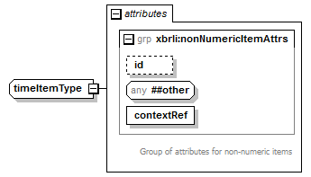
namespace | http://www.xbrl.org/2003/instance
type | extension of xsd:time
attributes
  Name | Type | Use | Default | Fixed
  id | xsd:ID | optional
  contextRef | xsd:IDREF | required

complexType tokenItemType
diagram | 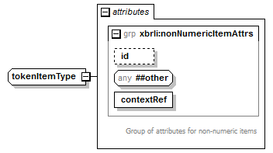
namespace | http://www.xbrl.org/2003/instance
type | extension of xsd:token
used by
  elements | CountryOrRegion MemberOfJurisdiction UniqueId
  complexTypes | ComplexityOfReportingProcessItemType DevelopmentStageItemType IndustryClassificationFinancialItemType IndustryClassificationNonFinancialSectorsItemType MarketRegulatorItemType NatureOfActivityItemType NatureOfTaxonomyProcessItemType OtherOrganizationsItemType PurposeOfProjectItemType ScopeItemType StatusItemType TaxonomyTypeItemType TypesOfDataItemType UsersOfRecordsItemType
attributes
  Name | Type | Use | Default | Fixed
  id | xsd:ID | optional
  contextRef | xsd:IDREF | required

complexType unsignedByteItemType
diagram | 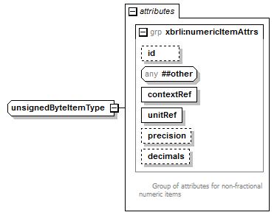
namespace | http://www.xbrl.org/2003/instance
type | extension of xsd:unsignedByte
attributes
  Name | Type | Use | Default | Fixed
  id | xsd:ID | optional
  contextRef | xsd:IDREF | required
  unitRef | xsd:IDREF | required
  precision | xbrli:precisionType | optional
  decimals | xbrli:decimalsType | optional

complexType unsignedIntItemType
diagram | 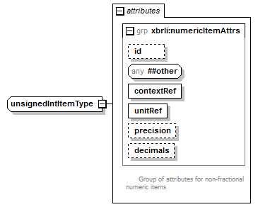
namespace | http://www.xbrl.org/2003/instance
type | extension of xsd:unsignedInt
attributes
  Name | Type | Use | Default | Fixed
  id | xsd:ID | optional
  contextRef | xsd:IDREF | required
  unitRef | xsd:IDREF | required
  precision | xbrli:precisionType | optional
  decimals | xbrli:decimalsType | optional

complexType unsignedLongItemType
diagram | 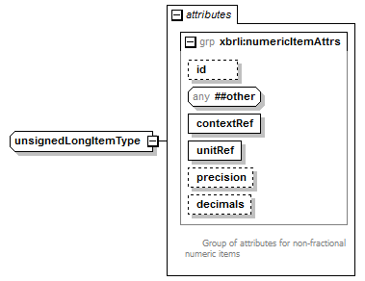
namespace | http://www.xbrl.org/2003/instance
type | extension of xsd:unsignedLong
attributes
  Name | Type | Use | Default | Fixed
  id | xsd:ID | optional
  contextRef | xsd:IDREF | required
  unitRef | xsd:IDREF | required
  precision | xbrli:precisionType | optional
  decimals | xbrli:decimalsType | optional

complexType unsignedShortItemType
diagram | 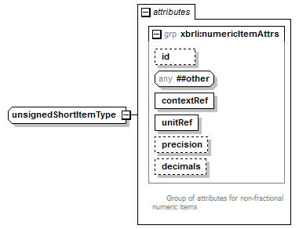
namespace | http://www.xbrl.org/2003/instance
type | extension of xsd:unsignedShort
attributes
  Name | Type | Use | Default | Fixed
  id | xsd:ID | optional
  contextRef | xsd:IDREF | required
  unitRef | xsd:IDREF | required
  precision | xbrli:precisionType | optional
  decimals | xbrli:decimalsType | optional

simpleType dateUnion
namespace | http://www.xbrl.org/2003/instance
type | union of (xsd:date, xsd:dateTime)
used by
  elements | contextPeriodType/endDate contextPeriodType/instant contextPeriodType/startDate
  complexType | dateTimeItemType

simpleType decimalsType
namespace | http://www.xbrl.org/2003/instance
type | union of (xsd:integer, restriction of xsd:string)
used by
  attribute | numericItemAttrs/@decimals

simpleType monetary
namespace | http://www.xbrl.org/2003/instance
type | xsd:decimal
used by
  complexType | monetaryItemType

simpleType nonZeroDecimal
namespace | http://www.xbrl.org/2003/instance
type | union of (restriction of xsd:decimal, restriction of xsd:decimal)
used by
  element | denominator

simpleType precisionType
namespace | http://www.xbrl.org/2003/instance
type | union of (xsd:nonNegativeInteger, restriction of xsd:string)
used by
  attribute | numericItemAttrs/@precision

simpleType pure
namespace | http://www.xbrl.org/2003/instance
type | xsd:decimal
used by
  complexType | pureItemType

simpleType shares
namespace | http://www.xbrl.org/2003/instance
type | xsd:decimal
used by
  complexType | sharesItemType

attributeGroup essentialNumericItemAttrs
namespace | http://www.xbrl.org/2003/instance
used by
  complexType | fractionItemType
  attributeGroup | numericItemAttrs
attributes
  Name | Type | Use | Default | Fixed
  id | xsd:ID | optional
  contextRef | xsd:IDREF | required
  unitRef | xsd:IDREF | required

attribute essentialNumericItemAttrs/@unitRef
type | xsd:IDREF

attributeGroup factAttrs
namespace | http://www.xbrl.org/2003/instance
used by
  attributeGroups | itemAttrs tupleAttrs
attributes
  Name | Type | Use | Default | Fixed
  id | xsd:ID | optional

attribute factAttrs/@id
type | xsd:ID

attributeGroup itemAttrs
namespace | http://www.xbrl.org/2003/instance
used by
  attributeGroups | essentialNumericItemAttrs nonNumericItemAttrs
attributes
  Name | Type | Use | Default | Fixed
  id | xsd:ID | optional
  contextRef | xsd:IDREF | required

attribute itemAttrs/@contextRef
type | xsd:IDREF

attributeGroup nonNumericItemAttrs
namespace | http://www.xbrl.org/2003/instance
used by
  complexTypes | anyURIItemType base64BinaryItemType booleanItemType ComplexityOfReportingProcessItemType dateItemType dateTimeItemType DevelopmentStageItemType durationItemType gDayItemType gMonthDayItemType gMonthItemType gYearItemType gYearMonthItemType hexBinaryItemType IndustryClassificationFinancialItemType IndustryClassificationNonFinancialSectorsItemType languageItemType MarketRegulatorItemType NameItemType NatureOfActivityItemType NatureOfTaxonomyProcessItemType NCNameItemType normalizedStringItemType OtherOrganizationsItemType PurposeOfProjectItemType QNameItemType ScopeItemType StatusItemType stringItemType TaxonomyTypeItemType timeItemType tokenItemType TypesOfDataItemType UsersOfRecordsItemType
attributes
  Name | Type | Use | Default | Fixed
  id | xsd:ID | optional
  contextRef | xsd:IDREF | required

attributeGroup numericItemAttrs
namespace | http://www.xbrl.org/2003/instance
used by
  complexTypes | byteItemType decimalItemType doubleItemType floatItemType integerItemType intItemType longItemType monetaryItemType negativeIntegerItemType nonNegativeIntegerItemType nonPositiveIntegerItemType positiveIntegerItemType pureItemType sharesItemType shortItemType unsignedByteItemType unsignedIntItemType unsignedLongItemType unsignedShortItemType
attributes
  Name | Type | Use | Default | Fixed
  id | xsd:ID | optional
  contextRef | xsd:IDREF | required
  unitRef | xsd:IDREF | required
  precision | xbrli:precisionType | optional
  decimals | xbrli:decimalsType | optional

attribute numericItemAttrs/@precision
type | xbrli:precisionType

attribute numericItemAttrs/@decimals
type | xbrli:decimalsType

attributeGroup tupleAttrs
namespace | http://www.xbrl.org/2003/instance
used by
  elements | ProjectHeader ProjectsList
attributes
  Name | Type | Use | Default | Fixed
  id | xsd:ID | optional

element arcroleRef
diagram | 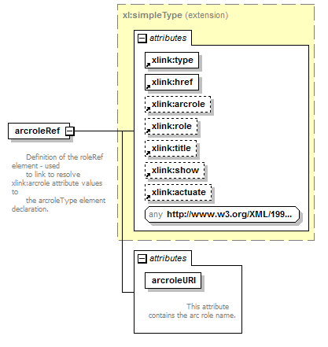
namespace | http://www.xbrl.org/2003/linkbase
type | extension of xl:simpleType
used by
  elements | linkbase xbrl
attributes
  Name | Type | Use | Default | Fixed
  type |  | required |  | simple
  href |  | required
  arcrole |  | optional
  role |  | optional
  title |  | optional
  show |  | optional
  actuate |  | optional
  arcroleURI | xl:nonEmptyURI | required

attribute arcroleRef/@arcroleURI
type | xl:nonEmptyURI

element arcroleType
diagram | 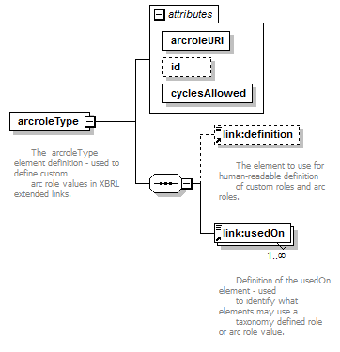
namespace | http://www.xbrl.org/2003/linkbase
children | link:definition link:usedOn
attributes
  Name | Type | Use | Default | Fixed
  arcroleURI | xl:nonEmptyURI | required
  id | xsd:ID
  cyclesAllowed | derived by: xsd:NMTOKEN | required

attribute arcroleType/@arcroleURI
type | xl:nonEmptyURI

attribute arcroleType/@id
type | xsd:ID

attribute arcroleType/@cyclesAllowed
type | restriction of xsd:NMTOKEN
facets
  Kind | Value
  enumeration | any
  enumeration | undirected
  enumeration | none

element calculationArc
diagram | 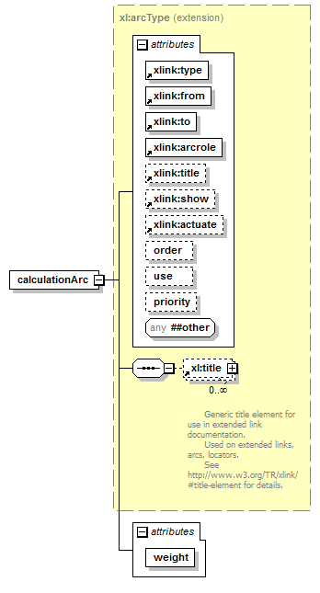
namespace | http://www.xbrl.org/2003/linkbase
type | extension of xl:arcType
children | xl:title
used by
  element | calculationLink
attributes
  Name | Type | Use | Default | Fixed
  type |  | required |  | arc
  from |  | required
  to |  | required
  arcrole |  | required
  title |  | optional
  show |  | optional
  actuate |  | optional
  order | xsd:decimal | optional
  use | xl:useEnum | optional
  priority | xsd:integer | optional
  weight | xsd:decimal | required

attribute calculationArc/@weight
type | xsd:decimal

element calculationLink
diagram | 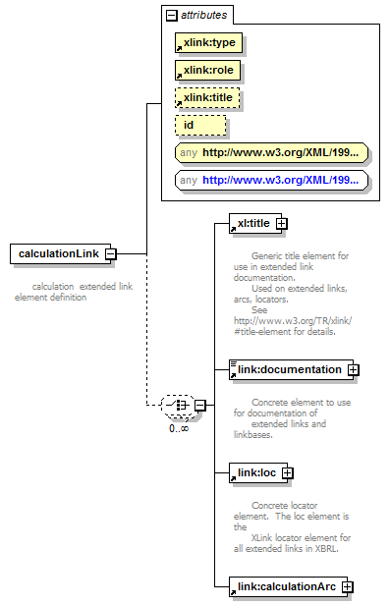
namespace | http://www.xbrl.org/2003/linkbase
type | restriction of xl:extendedType
children | xl:title link:documentation link:loc link:calculationArc
attributes
  Name | Type | Use | Default | Fixed
  type |  | required |  | extended
  role |  | required
  title |  | optional
  id | xsd:ID | optional

element definition
diagram | 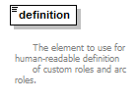
namespace | http://www.xbrl.org/2003/linkbase
type | xsd:string
used by
  elements | arcroleType roleType

element definitionArc
diagram | 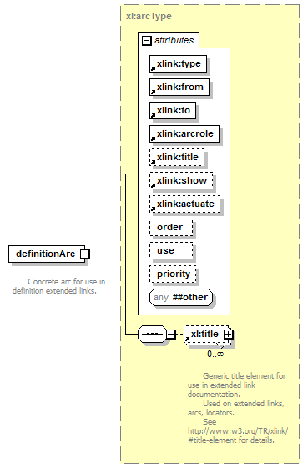
namespace | http://www.xbrl.org/2003/linkbase
type | xl:arcType
children | xl:title
used by
  element | definitionLink
attributes
  Name | Type | Use | Default | Fixed
  type |  | required |  | arc
  from |  | required
  to |  | required
  arcrole |  | required
  title |  | optional
  show |  | optional
  actuate |  | optional
  order | xsd:decimal | optional
  use | xl:useEnum | optional
  priority | xsd:integer | optional

element definitionLink
diagram | 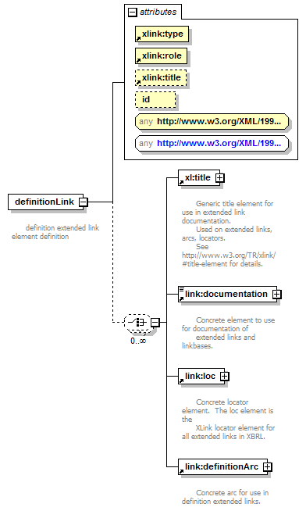
namespace | http://www.xbrl.org/2003/linkbase
type | restriction of xl:extendedType
children | xl:title link:documentation link:loc link:definitionArc
attributes
  Name | Type | Use | Default | Fixed
  type |  | required |  | extended
  role |  | required
  title |  | optional
  id | xsd:ID | optional

element documentation
diagram | 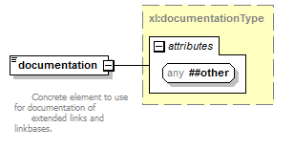
namespace | http://www.xbrl.org/2003/linkbase
type | xl:documentationType
used by
  elements | calculationLink definitionLink footnoteLink labelLink linkbase presentationLink referenceLink
attributes
  Name | Type | Use | Default | Fixed

element footnote
diagram | 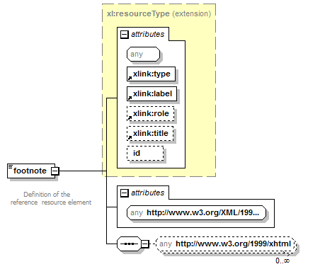
namespace | http://www.xbrl.org/2003/linkbase
type | extension of xl:resourceType
used by
  element | footnoteLink
attributes
  Name | Type | Use | Default | Fixed
  type |  | required |  | resource
  label |  | required
  role |  | optional
  title |  | optional
  id | xsd:ID | optional

element footnoteArc
diagram | 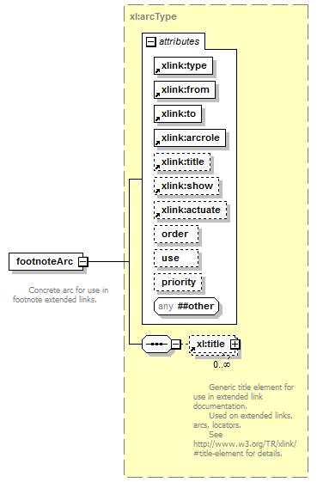
namespace | http://www.xbrl.org/2003/linkbase
type | xl:arcType
children | xl:title
used by
  element | footnoteLink
attributes
  Name | Type | Use | Default | Fixed
  type |  | required |  | arc
  from |  | required
  to |  | required
  arcrole |  | required
  title |  | optional
  show |  | optional
  actuate |  | optional
  order | xsd:decimal | optional
  use | xl:useEnum | optional
  priority | xsd:integer | optional

element footnoteLink
diagram | 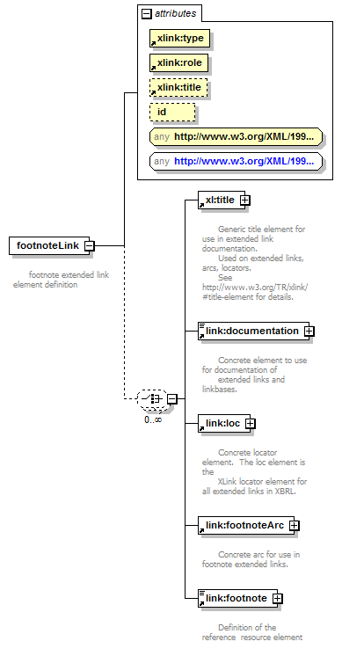
namespace | http://www.xbrl.org/2003/linkbase
type | restriction of xl:extendedType
children | xl:title link:documentation link:loc link:footnoteArc link:footnote
used by
  element | xbrl
attributes
  Name | Type | Use | Default | Fixed
  type |  | required |  | extended
  role |  | required
  title |  | optional
  id | xsd:ID | optional

element label
diagram | 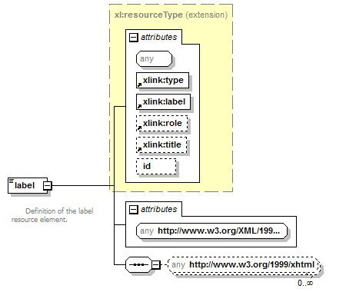
namespace | http://www.xbrl.org/2003/linkbase
type | extension of xl:resourceType
used by
  element | labelLink
attributes
  Name | Type | Use | Default | Fixed
  type |  | required |  | resource
  label |  | required
  role |  | optional
  title |  | optional
  id | xsd:ID | optional

element labelArc
diagram | 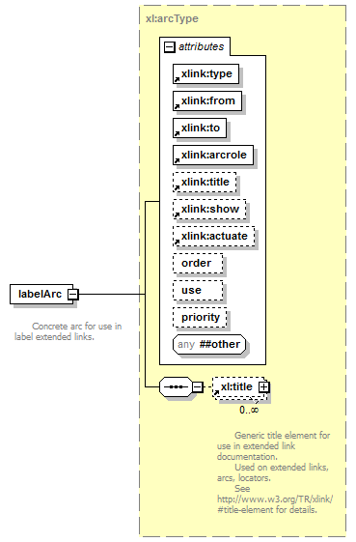
namespace | http://www.xbrl.org/2003/linkbase
type | xl:arcType
children | xl:title
used by
  element | labelLink
attributes
  Name | Type | Use | Default | Fixed
  type |  | required |  | arc
  from |  | required
  to |  | required
  arcrole |  | required
  title |  | optional
  show |  | optional
  actuate |  | optional
  order | xsd:decimal | optional
  use | xl:useEnum | optional
  priority | xsd:integer | optional

element labelLink
diagram | 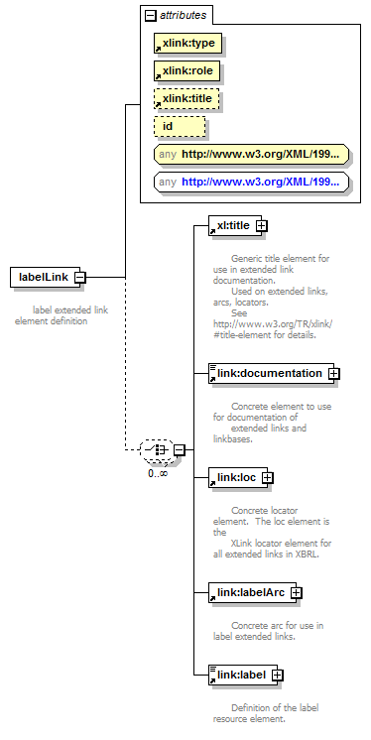
namespace | http://www.xbrl.org/2003/linkbase
type | restriction of xl:extendedType
children | xl:title link:documentation link:loc link:labelArc link:label
attributes
  Name | Type | Use | Default | Fixed
  type |  | required |  | extended
  role |  | required
  title |  | optional
  id | xsd:ID | optional

element linkbase
diagram | 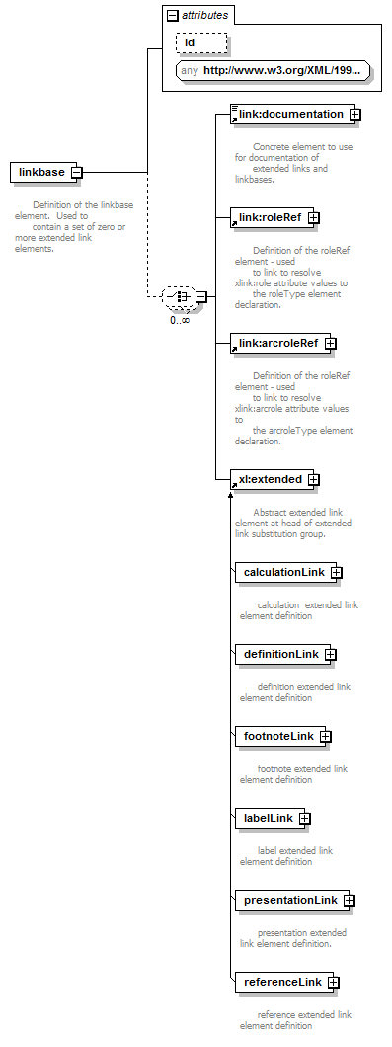
namespace | http://www.xbrl.org/2003/linkbase
children | link:documentation link:roleRef link:arcroleRef xl:extended
attributes
  Name | Type | Use | Default | Fixed
  id | xsd:ID | optional

attribute linkbase/@id
type | xsd:ID

element linkbaseRef
diagram | 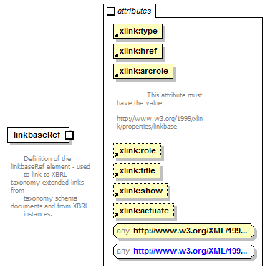
namespace | http://www.xbrl.org/2003/linkbase
type | restriction of xl:simpleType
used by
  element | xbrl
attributes
  Name | Type | Use | Default | Fixed
  type |  | required |  | simple
  href |  | required
  arcrole |  | required
  role |  | optional
  title |  | optional
  show |  | optional
  actuate |  | optional

element loc
diagram | 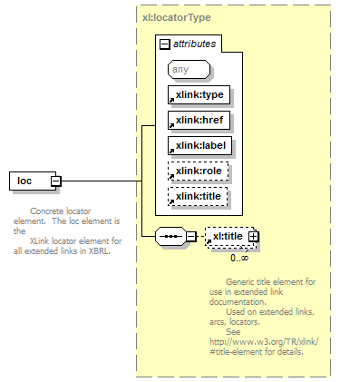
namespace | http://www.xbrl.org/2003/linkbase
type | xl:locatorType
children | xl:title
used by
  elements | calculationLink definitionLink footnoteLink labelLink presentationLink referenceLink
attributes
  Name | Type | Use | Default | Fixed
  type |  | required |  | locator
  href |  | required
  label |  | required
  role |  | optional
  title |  | optional

element part
diagram | 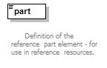
namespace | http://www.xbrl.org/2003/linkbase
type | xsd:anySimpleType
used by
  element | reference

element presentationArc
diagram | 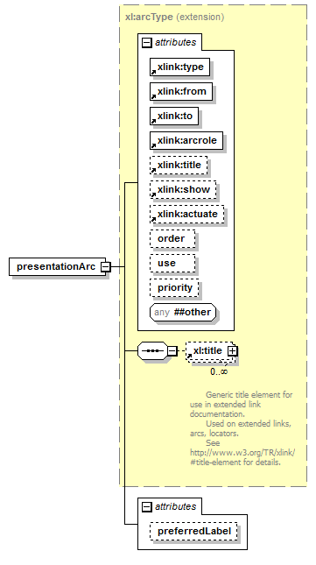
namespace | http://www.xbrl.org/2003/linkbase
type | extension of xl:arcType
children | xl:title
used by
  element | presentationLink
attributes
  Name | Type | Use | Default | Fixed
  type |  | required |  | arc
  from |  | required
  to |  | required
  arcrole |  | required
  title |  | optional
  show |  | optional
  actuate |  | optional
  order | xsd:decimal | optional
  use | xl:useEnum | optional
  priority | xsd:integer | optional
  preferredLabel | derived by: xsd:anyURI | optional

attribute presentationArc/@preferredLabel
type | restriction of xsd:anyURI

element presentationLink
diagram | 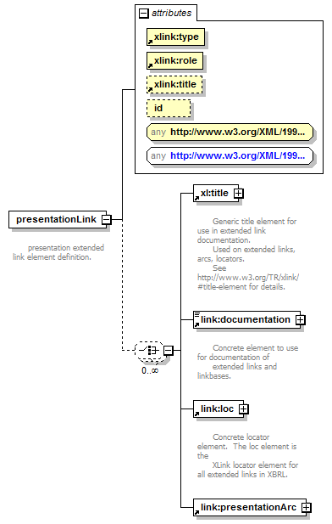
namespace | http://www.xbrl.org/2003/linkbase
type | restriction of xl:extendedType
children | xl:title link:documentation link:loc link:presentationArc
attributes
  Name | Type | Use | Default | Fixed
  type |  | required |  | extended
  role |  | required
  title |  | optional
  id | xsd:ID | optional

element reference
diagram | 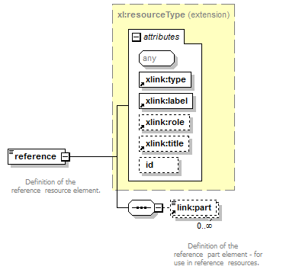
namespace | http://www.xbrl.org/2003/linkbase
type | extension of xl:resourceType
children | link:part
used by
  element | referenceLink
attributes
  Name | Type | Use | Default | Fixed
  type |  | required |  | resource
  label |  | required
  role |  | optional
  title |  | optional
  id | xsd:ID | optional

element referenceArc
diagram | 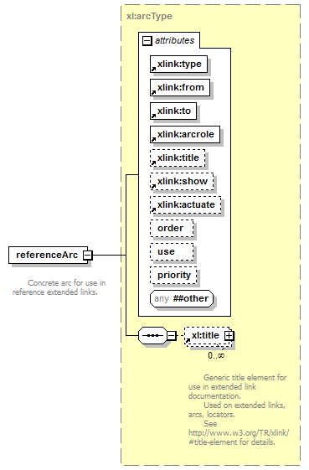
namespace | http://www.xbrl.org/2003/linkbase
type | xl:arcType
children | xl:title
used by
  element | referenceLink
attributes
  Name | Type | Use | Default | Fixed
  type |  | required |  | arc
  from |  | required
  to |  | required
  arcrole |  | required
  title |  | optional
  show |  | optional
  actuate |  | optional
  order | xsd:decimal | optional
  use | xl:useEnum | optional
  priority | xsd:integer | optional

element referenceLink
diagram | 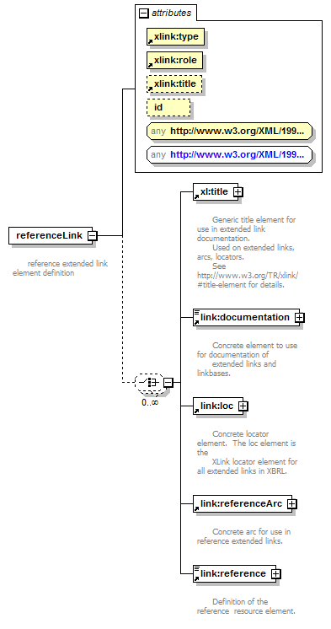
namespace | http://www.xbrl.org/2003/linkbase
type | restriction of xl:extendedType
children | xl:title link:documentation link:loc link:referenceArc link:reference
attributes
  Name | Type | Use | Default | Fixed
  type |  | required |  | extended
  role |  | required
  title |  | optional
  id | xsd:ID | optional

element roleRef
diagram | 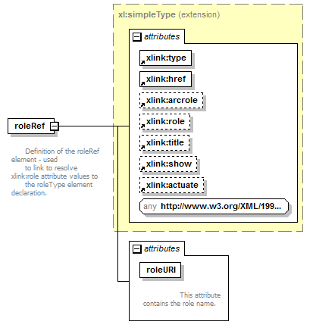
namespace | http://www.xbrl.org/2003/linkbase
type | extension of xl:simpleType
used by
  elements | linkbase xbrl
attributes
  Name | Type | Use | Default | Fixed
  type |  | required |  | simple
  href |  | required
  arcrole |  | optional
  role |  | optional
  title |  | optional
  show |  | optional
  actuate |  | optional
  roleURI | xl:nonEmptyURI | required

attribute roleRef/@roleURI
type | xl:nonEmptyURI

element roleType
diagram | 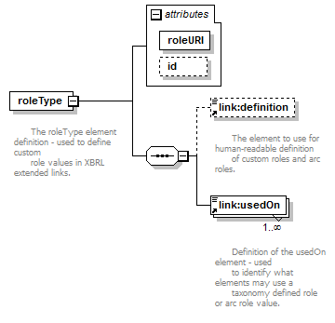
namespace | http://www.xbrl.org/2003/linkbase
children | link:definition link:usedOn
attributes
  Name | Type | Use | Default | Fixed
  roleURI | xl:nonEmptyURI | required
  id | xsd:ID

attribute roleType/@roleURI
type | xl:nonEmptyURI

attribute roleType/@id
type | xsd:ID

element schemaRef
diagram | 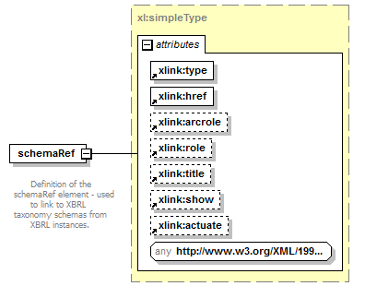
namespace | http://www.xbrl.org/2003/linkbase
type | xl:simpleType
used by
  element | xbrl
attributes
  Name | Type | Use | Default | Fixed
  type |  | required |  | simple
  href |  | required
  arcrole |  | optional
  role |  | optional
  title |  | optional
  show |  | optional
  actuate |  | optional

element usedOn
diagram | 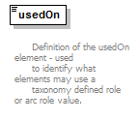
namespace | http://www.xbrl.org/2003/linkbase
type | xsd:QName
used by
  elements | arcroleType roleType

element arc
diagram | 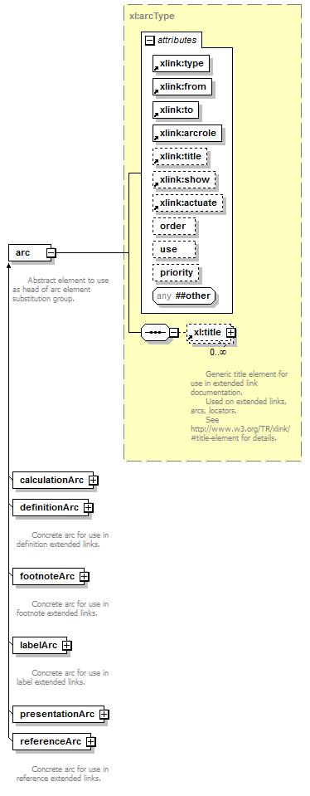
namespace | http://www.xbrl.org/2003/XLink
type | xl:arcType
children | xl:title
used by
  complexType | extendedType
attributes
  Name | Type | Use | Default | Fixed
  type |  | required |  | arc
  from |  | required
  to |  | required
  arcrole |  | required
  title |  | optional
  show |  | optional
  actuate |  | optional
  order | xsd:decimal | optional
  use | xl:useEnum | optional
  priority | xsd:integer | optional

element documentation
diagram | 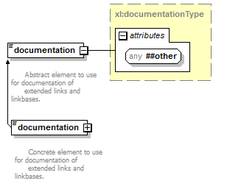
namespace | http://www.xbrl.org/2003/XLink
type | xl:documentationType
used by
  complexType | extendedType
attributes
  Name | Type | Use | Default | Fixed

element extended
diagram | 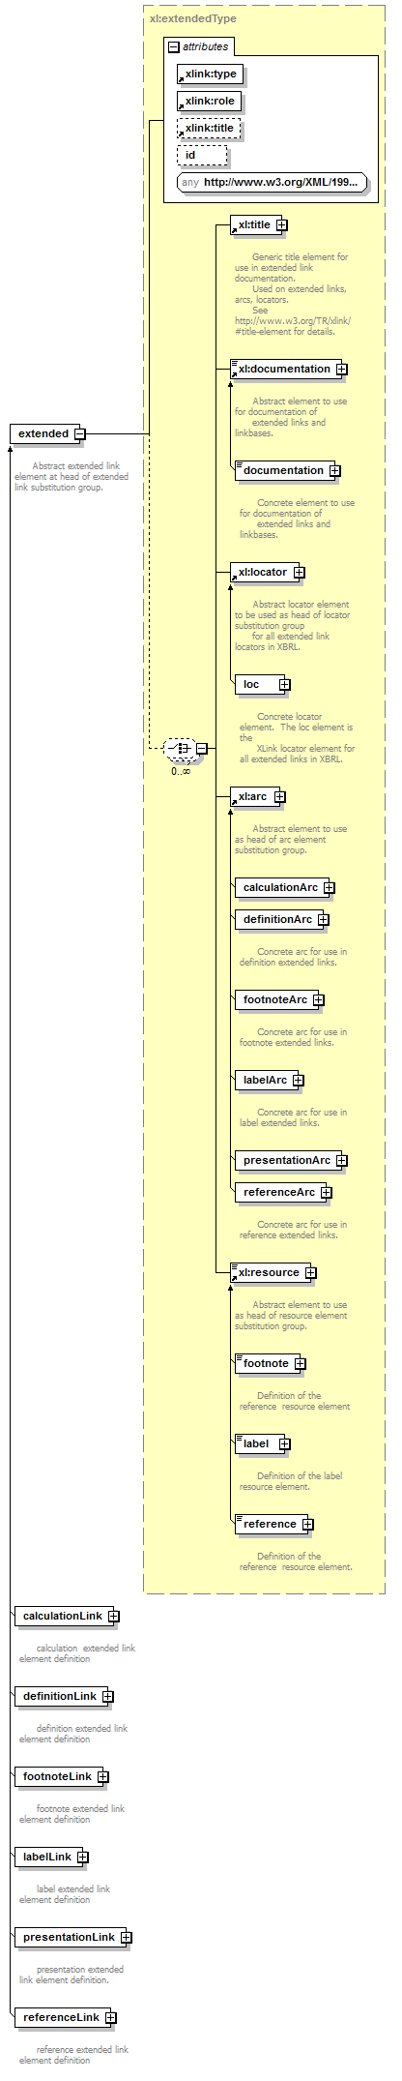
namespace | http://www.xbrl.org/2003/XLink
type | xl:extendedType
children | xl:title xl:documentation xl:locator xl:arc xl:resource
used by
  element | linkbase
attributes
  Name | Type | Use | Default | Fixed
  type |  | required |  | extended
  role |  | required
  title |  | optional
  id | xsd:ID | optional

element locator
diagram | 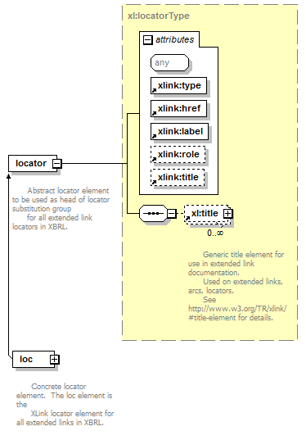
namespace | http://www.xbrl.org/2003/XLink
type | xl:locatorType
children | xl:title
used by
  complexType | extendedType
attributes
  Name | Type | Use | Default | Fixed
  type |  | required |  | locator
  href |  | required
  label |  | required
  role |  | optional
  title |  | optional

element resource
diagram | 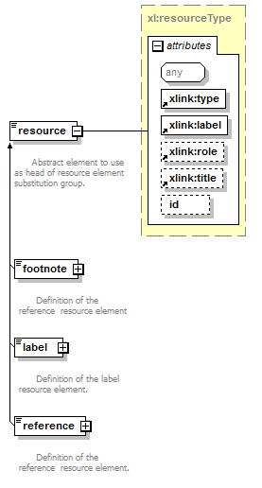
namespace | http://www.xbrl.org/2003/XLink
type | xl:resourceType
used by
  complexType | extendedType
attributes
  Name | Type | Use | Default | Fixed
  type |  | required |  | resource
  label |  | required
  role |  | optional
  title |  | optional
  id | xsd:ID | optional

element simple
diagram | 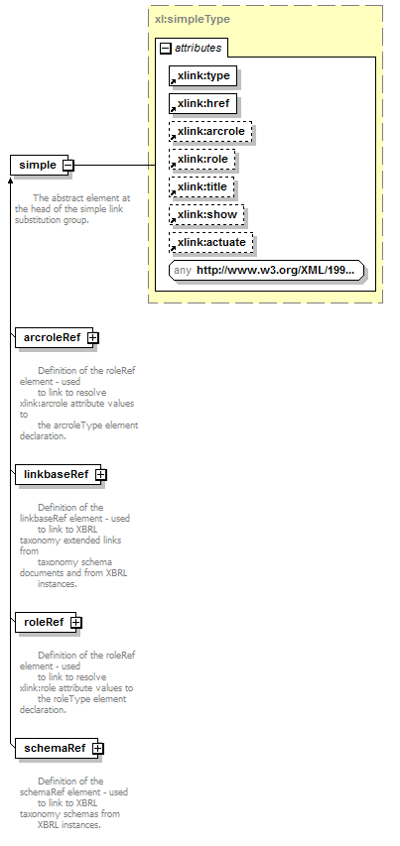
namespace | http://www.xbrl.org/2003/XLink
type | xl:simpleType
attributes
  Name | Type | Use | Default | Fixed
  type |  | required |  | simple
  href |  | required
  arcrole |  | optional
  role |  | optional
  title |  | optional
  show |  | optional
  actuate |  | optional

element title
diagram | 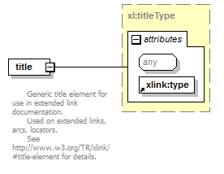
namespace | http://www.xbrl.org/2003/XLink
type | xl:titleType
used by
  elements | calculationLink definitionLink footnoteLink labelLink presentationLink referenceLink
  complexTypes | arcType extendedType locatorType
attributes
  Name | Type | Use | Default | Fixed
  type |  | required |  | title

complexType arcType
diagram | 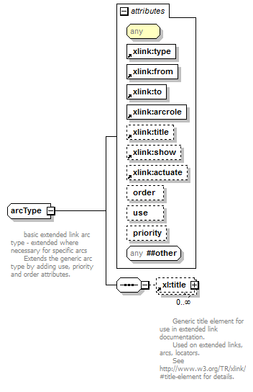
namespace | http://www.xbrl.org/2003/XLink
type | restriction of xsd:anyType
children | xl:title
used by
  elements | arc calculationArc definitionArc footnoteArc labelArc presentationArc referenceArc
attributes
  Name | Type | Use | Default | Fixed
  type |  | required |  | arc
  from |  | required
  to |  | required
  arcrole |  | required
  title |  | optional
  show |  | optional
  actuate |  | optional
  order | xsd:decimal | optional
  use | xl:useEnum | optional
  priority | xsd:integer | optional

attribute arcType/@order
type | xsd:decimal

attribute arcType/@use
type | xl:useEnum
facets
  Kind | Value
  enumeration | optional
  enumeration | prohibited

attribute arcType/@priority
type | xsd:integer

complexType documentationType
diagram | 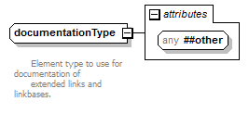
namespace | http://www.xbrl.org/2003/XLink
type | extension of xsd:string
used by
  elements | documentation documentation
attributes
  Name | Type | Use | Default | Fixed

complexType extendedType
diagram | 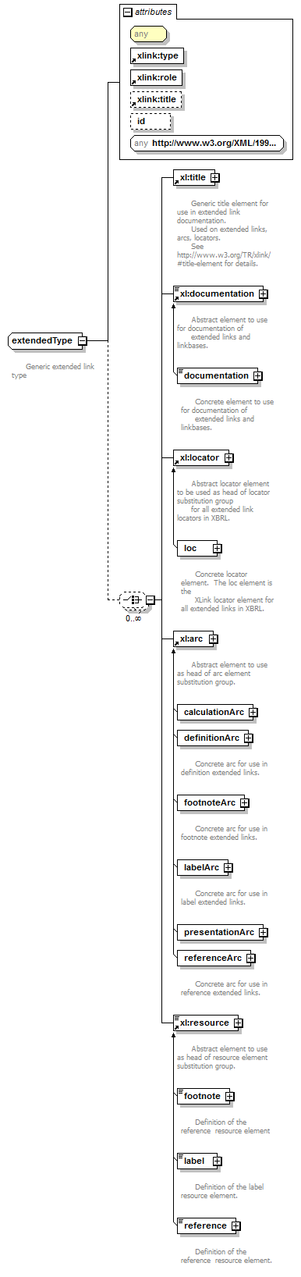
namespace | http://www.xbrl.org/2003/XLink
type | restriction of xsd:anyType
children | xl:title xl:documentation xl:locator xl:arc xl:resource
used by
  elements | calculationLink definitionLink extended footnoteLink labelLink presentationLink referenceLink
attributes
  Name | Type | Use | Default | Fixed
  type |  | required |  | extended
  role |  | required
  title |  | optional
  id | xsd:ID | optional

attribute extendedType/@id
type | xsd:ID

complexType locatorType
diagram | 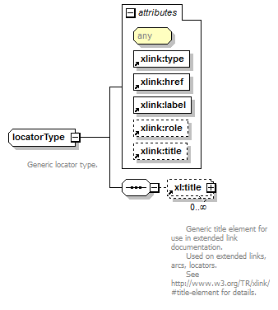
namespace | http://www.xbrl.org/2003/XLink
type | restriction of xsd:anyType
children | xl:title
used by
  elements | loc locator
attributes
  Name | Type | Use | Default | Fixed
  type |  | required |  | locator
  href |  | required
  label |  | required
  role |  | optional
  title |  | optional

complexType resourceType
diagram | 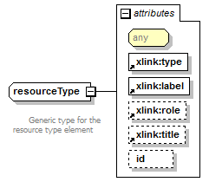
namespace | http://www.xbrl.org/2003/XLink
type | restriction of xsd:anyType
used by
  elements | footnote label reference resource
attributes
  Name | Type | Use | Default | Fixed
  type |  | required |  | resource
  label |  | required
  role |  | optional
  title |  | optional
  id | xsd:ID | optional

attribute resourceType/@id
type | xsd:ID

complexType simpleType
diagram | 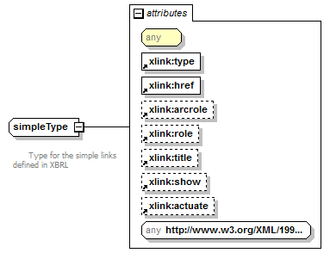
namespace | http://www.xbrl.org/2003/XLink
type | restriction of xsd:anyType
used by
  elements | arcroleRef linkbaseRef roleRef schemaRef simple
attributes
  Name | Type | Use | Default | Fixed
  type |  | required |  | simple
  href |  | required
  arcrole |  | optional
  role |  | optional
  title |  | optional
  show |  | optional
  actuate |  | optional

complexType titleType
diagram | 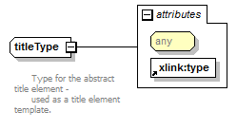
namespace | http://www.xbrl.org/2003/XLink
type | restriction of xsd:anyType
used by
  element | title
attributes
  Name | Type | Use | Default | Fixed
  type |  | required |  | title

simpleType nonEmptyURI
namespace | http://www.xbrl.org/2003/XLink
type | restriction of xsd:anyURI
used by
  attributes | arcroleRef/@arcroleURI arcroleType/@arcroleURI roleRef/@roleURI roleType/@roleURI

simpleType useEnum
namespace | http://www.xbrl.org/2003/XLink
type | restriction of xsd:NMTOKEN
used by
  attribute | arcType/@use
facets
  Kind | Value
  enumeration | optional
  enumeration | prohibited

attribute actuate
namespace | http://www.w3.org/1999/xlink
type | restriction of xsd:string
used by
  complexTypes | arcType simpleType
facets
  Kind | Value
  enumeration | onLoad
  enumeration | onRequest
  enumeration | other
  enumeration | none

attribute arcrole
namespace | http://www.w3.org/1999/xlink
type | restriction of xsd:anyURI
used by
  element | linkbaseRef
  complexTypes | arcType simpleType

attribute from
namespace | http://www.w3.org/1999/xlink
type | xsd:NCName
used by
  complexType | arcType

attribute href
namespace | http://www.w3.org/1999/xlink
type | xsd:anyURI
used by
  complexTypes | locatorType simpleType

attribute label
namespace | http://www.w3.org/1999/xlink
type | xsd:NCName
used by
  complexTypes | locatorType resourceType

attribute role
namespace | http://www.w3.org/1999/xlink
type | restriction of xsd:anyURI
used by
  complexTypes | extendedType locatorType resourceType simpleType

attribute show
namespace | http://www.w3.org/1999/xlink
type | restriction of xsd:string
used by
  complexTypes | arcType simpleType
facets
  Kind | Value
  enumeration | new
  enumeration | replace
  enumeration | embed
  enumeration | other
  enumeration | none

attribute title
namespace | http://www.w3.org/1999/xlink
type | xsd:string
used by
  complexTypes | arcType extendedType locatorType resourceType simpleType

attribute to
namespace | http://www.w3.org/1999/xlink
type | xsd:NCName
used by
  complexType | arcType

attribute type
namespace | http://www.w3.org/1999/xlink
type | restriction of xsd:string
used by
  complexTypes | arcType extendedType locatorType resourceType simpleType titleType
facets
  Kind | Value
  enumeration | simple
  enumeration | extended
  enumeration | locator
  enumeration | arc
  enumeration | resource
  enumeration | title

XML Schema documentation generated by XMLSpy Schema Editor http://www.altova.com/xmlspy

